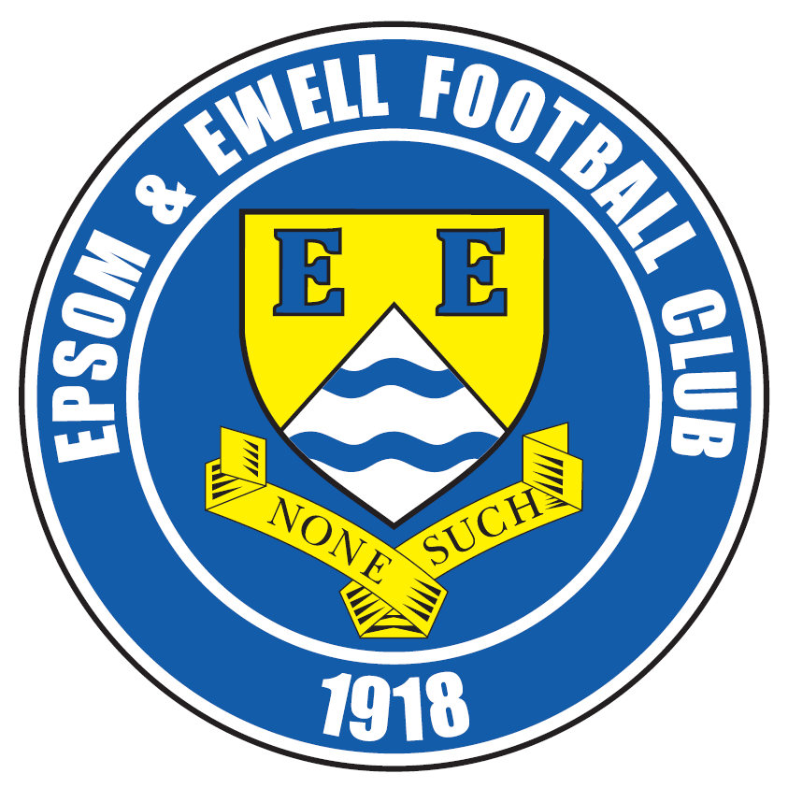 | Epsom & Ewell F.C.  13  v  Guildford City  Saturday, 5th December 2015
Good afternoon! We welcome the players, supporters and officials of Guildford City, together with today’s officials and our own regular faces.

Last season was our opponents first back at this level, following relegation from the Southern League and we completed a League double; 4-1 here and 3-1 at The Spectrum. This season our opponents look to have stabilised matters following their battle against relegation last year, but results remain inconsistent, having won 9-3 at Chessington & Hook United but losing 2-0 at Cove.

When playing a team capable of such highs and lows it is even more important than usual to concentrate on our own performance. We have played much better this season against teams around us than we have against those in the bottom half and I am sure our Management are aware of this too.

A case in point happened in the last seven days when we were fortunate in the end to get a point from Bedfont Sports in a 2-2 draw. However, this game was filled with controversy after a string of very poor decisions led to enormous frustration and two of our players were sent off. We know that Matt Tanton will miss the game against Cove in three days as a result, but for Daryl Cooper-Smith, things are more complicated as he has been hit with a misconduct charge and has found himself immediately suspended as a result. Hopefully common sense will prevail at any hearing and we will see him back in Epsom colours shortly.

Our most recent game was last Saturday where we faced a tricky looking challenge from Colliers Wood United, but we nullified their threats well and ran away with it in the second half. Daryl scored twice; one with each foot and it was also good to see Kyle Hough back, poaching a goal and having another chalked off for reasons that are still not entirely clear.

It was an important win as all those around us also won, and with our next four matches against teams in the bottom eight we have to remain prepared to work as hard as we did on Saturday or we will slip back from the leaders.

Following today’s match, and as advised above, we host Cove on Tuesday before travelling to Ash United on Saturday where we face Badshot Lea. Then in exactly two weeks we will be hosting Sutton Common Rovers in a League match. If you can’t make the Cove match, why not come to that one? Better still, do both!

I know I keep repeating this, but we are in desperate need of further sponsorship; both for the matches and for our own players and staff. Please help your club, as every donation helps!

Enjoy the game!

Rich

You can now follow us on Facebook www.facebook.com/epsomandewellfc or Twitter @EEFCOfficial

Cover Photos by Gemma Jarman

- Kyle Hough reacts first to score our second goal at Colliers Wood on Saturday
- Tom Neale and Reisse Griffin celebrate Daryl Cooper-Smith’s opener at Bedfont Sports


Cherry Red Records Combined Counties League
Premier Division Table 2015/16
inc Tuesday 1st December | P | W | D | L | F | A | Pts | GD | H | A
Hartley Wintney | 18 | 15 | 2 | 1 | 62 | 18 | 47 | +44 | 30/1 | 3-3
Ashford Town (Mx) | 18 | 14 | 0 | 4 | 42 | 21 | 42 | +21 | 30/4 | 3-2
Epsom & Ewell | 18 | 11 | 6 | 1 | 44 | 17 | 39 | +27 | X | X
Camberley Town | 16 | 11 | 3 | 2 | 30 | 14 | 36 | +16 | 16/4 | 20/2
Horley Town | 16 | 10 | 2 | 4 | 40 | 19 | 32 | +21 | 27/2 | 28/12
Hanworth Villa | 18 | 10 | 1 | 7 | 35 | 28 | 31 | +7 | 5-0 | 23/4
Colliers Wood United | 21 | 8 | 1 | 12 | 43 | 39 | 25 | +4 | 3-1 | 3-0
Windsor | 17 | 6 | 7 | 4 | 32 | 34 | 25 | -2 | 2-2 | 23/1
Raynes Park Vale | 18 | 8 | 0 | 10 | 37 | 39 | 24 | -2 | 3-1 | 28/3
AFC Hayes | 19 | 7 | 3 | 9 | 29 | 33 | 24 | -4 | 1-1 | 9/1
Spelthorne Sports | 18 | 7 | 3 | 8 | 31 | 37 | 24 | -6 | 16/1 | 6-2
Knaphill | 16 | 7 | 2 | 7 | 27 | 19 | 23 | +8 | 12/3 | 1-1
Westfield | 16 | 6 | 5 | 5 | 21 | 24 | 23 | -3 | 26/3 | 0-0
Chessington & Hook | 18 | 7 | 2 | 9 | 33 | 38 | 23 | -5 | 1-0 | 19/3
Guildford City | 19 | 7 | 2 | 10 | 39 | 46 | 23 | -7 | 5/12 | 2/4
Farnham Town | 17 | 6 | 3 | 8 | 28 | 26 | 21 | +3 | 1-0 | 6/2
Sutton Common Rovers | 18 | 6 | 3 | 9 | 28 | 36 | 21 | -8 | 19/12 | 2-1
Badshot Lea | 18 | 6 | 1 | 11 | 24 | 49 | 19 | -25 | 9/4 | 12/12
Chertsey Town | 18 | 4 | 5 | 9 | 16 | 27 | 17 | -11 | 0-1 | 5/3
Bedfont Sports | 17 | 3 | 7 | 7 | 23 | 26 | 16 | -3 | 13/2 | 2-2
Redhill | 16 | 3 | 2 | 11 | 23 | 40 | 11 | -17 | 2/1 | 1-0
Cove | 16 | 1 | 0 | 15 | 8 | 65 | 3 | -57 | 8/12 | 7-0

Lucky Day? – 5th December
Played 16 - W 7 D 2 L 7 - F 28 A 40 - PPG 1.44 - Average
Our Club record against the current Guildford City
Played 14 - W 7 D 1 L 6 - F 23 A 21 - PPG 1.57 - Above Average
Largest wins and losses against our opponent
13th August 2008 - W 4-0 - League - 14th September 2010 - L 1-5 - League
Last visit
Tuesday 30th September 2014 - W 4-1 - Combined Counties League

Club Assistant Manager – Matt Smith
Good afternoon and welcome to High Road for our game against Guildford City.

We come into today's game in some good form and after a frustrating result against Bedfont, a good result on Saturday has us back on track.

It felt like two big points dropped against Bedfont. We were in full control of the game and even though we had our chances to kill the game off we were punished by some very poor decisions from the officials who in my eyes ruined the game.

Saturday’s game against Colliers Wood was now a massive game to get us back to winning ways. After an average first half performance by our standards we went in at half time 0-0. Trying to be as positive as possible, the team talk allowed us time to re-group and organise a few things which seemed to pay off as the second half was a great performance in which we controlled the game and scored three goals. Credit to all the players who showed a great attitude and discipline to go and win the game.

We will all continue to work hard and keep the good performances and results going to the end of the season.

Thank you all for your great support and hope Guildford enjoy their afternoon at High Road for what I believe will be a good, exciting game.

Smudge

Club Captain - Sam Currie
Good afternoon and welcome to High Road for today’s game versus Guildford City.

After three solid performances which have seen us accumulate seven points out of nine with two of those matches being away, we are looking to improve and extend this run today.

We have put behind us the strange evening away at Bedfont Sports and we were on song with a solid second half performance against Colliers Wood in our latest outing.

We are sure today will be a solid test and we know we will have to be at our best to gain three points today.

With the inclusion in the squad of Carl “Downsey”, Martin Merrett and Steve Rowe we have reinforcements in place and are ready to attack the winter period into the new year and stay involved at the top end of the table.


We hope you enjoy today’s game and we wish all the Guildford City players, coaching staff and supporters a safe journey home after the game.

All the best and thank you for your continued support as always.

Sam

Latest Results and Fixtures
Surrey Senior Cup Second Round – Thursday 19th November
Horley Town | 2-2 | Badshot Lea
Badshot Lea won 4-3 on penalties
F.A. Vase Second Round – Friday 20th November
Sutton Common Rovers | 3-2 | Beckenham Town
F.A. Vase Second Round – Saturday 21st November
Colliers Wood United | 2-0 | Loxwood
Hartley Wintney | 3-1 | Windsor
Knaphill | 3-0 | Tunbridge Wells
Newhaven | 1-2 | Camberley Town
Combined Counties League – Saturday 21st November
Badshot Lea | 2-1 | Guildford City
Chertsey Town | 3-1 | Cove
Epsom & Ewell | 5-0 | Hanworth Villa
Farnham Town | 1-2 | Ashford Town (Mx)
Horley Town | 2-1 | Bedfont Sports
Westfield | 2-1 | Chessington & Hook United
Combined Counties League – Monday 23rd November
Sutton Common Rovers | 2-1 | Knaphill
Combined Counties League – Tuesday 24th November
Bedfont Sports | 2-2 | Epsom & Ewell
Hanworth Villa | 1-2 | Colliers Wood United
Hartley Wintney | 2-3 | Badshot Lea
Combined Counties League – Saturday 28th November
AFC Hayes | 1-1 | Farnham Town
Badshot Lea | 0-4 | Hanworth Villa
Camberley Town | 4-2 | Guildford Town
Colliers Wood United | 0-3 | Epsom & Ewell
Cove | 0-4 | Horley Town
Knaphill | 3-1 | Bedfont Sports
Raynes Park Vale | 2-0 | Chertsey Town
Redhill | 0-5 | Hartley Wintney
Spelthorne Sports | 0-3 | Ashford Town (Mx)
Westfield | 1-1 | Sutton Common Rovers
Windsor | 4-3 | Chessington & Hook United
Surrey Senior Cup Second Round – Tuesday 1st December
Knaphill | 4-3 | Ashford Town (Mx)
Westfield | 2-0 | Chertsey Town
Combined Counties League – Tuesday 1st December
Hanworth Villa | 5-0 | Raynes Park Vale
Hartley Wintney | 2-1 | Sutton Common Rovers
Windsor | 2-3 | AFC Hayes
Latest Results and Fixtures
Surrey Senior Cup Second Round – Wednesday 2nd December
Colliers Wood United | 1-3 | Whyteleafe
Croydon | 3-3 | Farnham Town
Farnham Town win 3-2 on penalties
Redhill | 0-3 | Tooting & Mitcham United
Combined Counties League – Saturday 5th December
Ashford Town (Mx) | V | Horley Town
Bedfont Sports | V | Badshot Lea
Camberley Town | V | Chertsey Town
Chessington & Hook United | V | Spelthorne Sports
Epsom & Ewell | V | Guildford City
Farnham Town | V | Colliers Wood United
Hanworth Villa | V | Westfield
Hartley Wintney | V | Windsor
Knaphill | V | Raynes Park Vale
Redhill | V | AFC Hayes
Sutton Common Rovers | V | Cove
Combined Counties League – Monday 7th December
Sutton Common Rovers | V | Hanworth Villa
Combined Counties League – Tuesday 8th December
Bedfont Sports | V | Chessington & Hook United
Epsom & Ewell | V | Cove
Hartley Wintney | V | Chertsey Town
Windsor | V | Horley Town
Combined Counties League – Wednesday 9th December
Colliers Wood United | V | Raynes Park Vale
F.A. Vase Third Round – Saturday 12th December
Ascot United | V | Camberley Town
Canterbury City | V | Knaphill
Colliers Wood United | V | Hartley Wintney
Eastbourne Town | V | Sutton Common Rovers
Combined Counties League – Saturday 12th December
AFC Hayes | V | Chessington & Hook United
Badshot Lea | V | Epsom & Ewell
Chertsey Town | V | Farnham Town
Cove | V | Hanworth Villa
Guildford City | V | Ashford Town (Mx)
Raynes Park Vale | V | Spelthorne Sports
Westfield | V | Redhill
Combined Counties League Cup Third Round – Tuesday 15th December
Camberley Town | V | Spelthorne Sports
Cobham | V | Frimley Green
Latest Results and Fixtures
Combined Counties League Cup Third Round – Tuesday 15th December
Hartley Wintney | V | Chessington & Hook United
Knaphill | V | Chertsey Town
Raynes Park Vale | V | Westfield
Redhill | V | Farnham Town
Combined Counties League – Tuesday 15th December
Windsor | V | Sutton Common Rovers
Combined Counties League Cup Third Round – Wednesday 16th December
Colliers Wood United | V | Dorking Wanderers Reserves
Combined Counties League – Saturday 19th December
AFC Hayes | V | Ashford Town (Mx)
Badshot Lea | V | Farnham Town
Bedfont Sports | V | Camberley Town
Colliers Wood United | V | Knaphill
Epsom & Ewell | V | Sutton Common Rovers
Guildford City | V | Chertsey Town
Hartley Wintney | V | Hanworth Villa
Raynes Park Vale | V | Horley Town
Redhill | V | Chessington & Hook United
Westfield | V | Cove
Windsor | V | Spelthorne Sports

Player Profile – Number 9 – Beckett Oliver

Our latest player profile is from one of our new players this season, Beckett Oliver.

Age: 20

Position: Winger

Club supported: Chelsea

Favourite Food: Rice

Favourite Film: Drive

Messi or Ronaldo: Messi

Favourite Drink: Fanta Lemon

Favourite Ground played at: Craven Cottage, Fulham FC

Best moment for Epsom: Getting to know all the lads

Describe the Gaffa in three words: Virgin - Media - Advert

Beckett’s Playing Stats: First Team Debut : 29/08/2015

Appearances: 5 - Sub: 7 - Total: 12 - Goals: 0

First Eleven Appearances - (max 22 – including Colliers Wood – 28/11/15)
Name | Debut | 2014/15 |  |  |  | Career Totals
Name | Debut | App | Sub | Total | Goals | App | Sub | Total | Goals
AJAYI Tayo | 22/08/2015 | 0 | 2 | 2 | 0 | 0 | 2 | 2 | 0
COOPER-SMITH Daryl | 03/01/2015 | 15 | 4 | 19 | 8 | 24 | 7 | 31 | 14
CURRIE Sam | 04/08/2012 | 16 | 1 | 17 | 1 | 124 | 10 | 134 | 3
DAVISON Conor* | 22/08/2015 | 1 | 2 | 3 | 0 | 1 | 2 | 3 | 0
DEAN Dan | 02/08/2014 | 14 | 2 | 16 | 0 | 50 | 3 | 53 | 0
DEWAR Ali | 29/10/2011 | 0 | 0 | 0 | 0 | 55 | 35 | 90 | 10
DOWNS Carl | 17/09/2011 | 0 | 1 | 1 | 0 | 94 | 14 | 108 | 2
EACOTT Michael | 02/08/2014 | 19 | 0 | 19 | 0 | 65 | 0 | 65 | 0
FARRELL Matt | 02/08/2014 | 21 | 0 | 21 | 4 | 62 | 3 | 65 | 11
FERDINANDO Matt | 20/09/2014 | 15 | 0 | 15 | 4 | 42 | 4 | 46 | 10
GRIFFIN Reisse | 08/08/2015 | 7 | 4 | 11 | 0 | 7 | 4 | 11 | 0
HASTINGS Craig | 08/08/2015 | 15 | 3 | 18 | 0 | 15 | 3 | 18 | 0
HENDRY Rob | 08/08/2015 | 20 | 1 | 21 | 8 | 20 | 1 | 21 | 8
HOUGH Kyle | 14/08/2007 | 16 | 2 | 18 | 13 | 312 | 17 | 329 | 184
JONES Adrian | 06/08/2011 | 2 | 0 | 2 | 0 | 22 | 0 | 22 | 0
KURDZIEL Jakub | 29/08/2015 | 1 | 0 | 1 | 0 | 1 | 0 | 1 | 0
MARVELL Dale* | 15/01/2000 | 8 | 4 | 12 | 1 | 269 | 49 | 318 | 86
MCGREGOR Alex | 08/08/2009 | 7 | 2 | 9 | 2 | 179 | 58 | 237 | 29
MCKAY Alex | 20/12/2008 | 13 | 1 | 14 | 0 | 98 | 27 | 125 | 8
NEALE Thomas | 13/10/2015 | 3 | 7 | 10 | 2 | 3 | 7 | 10 | 2
NEILL David* | 03/10/2015 | 1 | 1 | 2 | 0 | 1 | 1 | 2 | 0
NORTH Rhys | 16/08/2015 | 5 | 6 | 11 | 0 | 5 | 6 | 11 | 0
OLIVER Beckett | 29/08/2015 | 5 | 7 | 12 | 0 | 5 | 7 | 12 | 0
PANAYIOTOU Savvas* | 03/01/2015 | 2 | 0 | 2 | 0 | 18 | 3 | 21 | 3
SMITH Matt | 08/08/2009 | 0 | 0 | 0 | 0 | 91 | 43 | 134 | 10
TANTON Matt | 02/08/2014 | 19 | 0 | 19 | 0 | 37 | 4 | 41 | 1
TAYLOR James | 26/08/2013 | 17 | 2 | 19 | 2 | 73 | 10 | 83 | 5
Own Goal |  |  |  |  |  |  |  |  | 1
* Player has left the club

Match report by Sam Brooker
Epsom & Ewell 5-0 Hanworth Villa
Combined Counties League – Premier Division - Saturday 21st November 2015

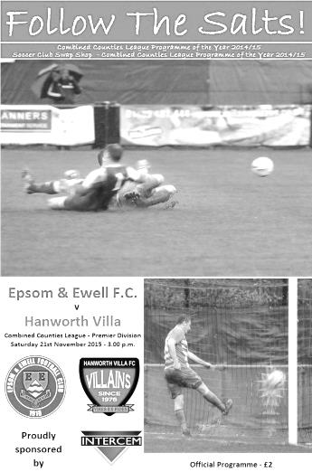
Epsom well worth their Salt

Our latest home encounter was against sixth placed Hanworth Villa. We boasted a full bench; however, the majority weren't at optimum levels of fitness. Notably, Kyle Hough nursing an injury after playing an hour in Tuesday's draw against league leaders Hartley Wintney, Alex McKay had also limped off during the same fixture, but Dan Dean had returned after his recovery period, starting on the bench as he still isn't back to match fitness yet. Also Captain Sam Currie was out with a groin injury, and in light of this, Matt Farrell was temporary Captain.

The Salts initiated the game at a blistering pace, our early pressure forcing a corner inside the opening minute. This foreshadowed what was to come in the remaining 89 minutes. Several probing balls were sent in behind the Hanworth defence, and with Tom Neale getting on the end of many, caused havoc amongst the red opposition's backline. However, the away side handled the situations confidently at first, especially the captain's (Adam Baigent) expert cover tackle on Neale as he began to propel down the left wing.

The first clear chance resulted from some superb skill and tenacity on the right flank by Reisse Griffin who then laid the ball back to Rhys North, the latter delivered the ball, first time, into Daryl Cooper-Smith who made excellent contact with the ball and rattled the crossbar in the 7th minute. This sparked Hanworth Villa into life as Kamaron English skipped past Griffin, before passing to his strike partner who was brought down marginally outside of our box by James Taylor. Former Salt Dale Marvell insisted on taking the consequential set piece, luckily, this chance was squandered as it was struck directly at the solid Epsom wall.

Both teams played with excellent width and the ball was mostly kept on the ground, allowing crisp, skilful play to develop. This allowed our boys to create another chance in the 12th minute, on this occasion, via Matt Tanton's lethally accurate cross which was desperately fumbled into the keeper's gloves by Tom Dilloway. The rapid pace of the match was only slowed by the over-sensitive decisions by the referee.

The opening goal occurred in the 18th minute, stemming from a corner that was drilled low by Matt Ferdinando which was cleared away for another corner. With his second attempt, Ferdinando floated his delivery beyond the head of the first defender and onto that of the onrushing James Taylor who stooped to power the header into the ground, it then bounced up to beat Adam Willis and nestle in the right hand corner of the Hanworth goal - Taylor's first goal of the season!

Conceding the goal seemed to motivate the away side as the game found a new gear. Cooper-Smith tried his luck from distance (not for the last time in the match) and very nearly caught Willis off of his line, following Ferdinando's attempted pick-pocket of the goalkeeper. We continued to put pressure on the keeper as Ferdinando released a stinging shot from outside of the box, which was palmed for a corner. As a result, Willis was booked in the 24th minute for dissent. Our boys

almost capitalised on this pressure as Taylor headed home in off the far post from another Ferdinando corner, however, this was disallowed as the ball was deemed to have gone out of play before coming in. The game, up to this point, had been largely dominated by the referee rather than performances from the players.

Epsom and Ewell executed an impressive defensive performance too, with everyone performing their defensive duties well, as demonstrated by Rhys North shepherding English down the line, without committing, before he ran out of room and rolled the ball out of bounds. This appeared to be the difference between the two sides in the first half - their composure at the back.

Cooper-Smith continued to look lively with a whistling shot that zipped across the goal and won a corner, this was followed up by North curling a shot goal-ward, unfortunately, it was directed straight at Willis. In the 44th minute, both Craig Hastings and North cleared two shots off of the line to maintain the 1-0 lead. Some intricate play between Griffin and Ferdinando dissected the defence and Griffin nearly slotted a goal, but the keeper managed to get enough contact to keep the Salts out. Eacott then followed suit as he smothered the counter attack to bring the first half to a close.

The opening goal of the second half came in the 52nd minute, Neale spread the ball out to Rob Hendry in space on the left, after a sublime touch, Hendry bent the ball with his right foot inside the keeper's right hand post. We then played some skilful, composed, one or two touch football in order to maintain possession and therefore, control over our 2-0 lead. This nullified the attacking speed of Hanworth Villa who had proved to be a handful on the counter-attack. Ferdinando continued along the same vein as he had been throughout the match, with a terrific flick on around the corner to Cooper-Smith in our own half, where with a driving run he got himself in front of the defenders, allowing him to square the ball to Neale, creating a one on one with the goalkeeper who got down well to his left to deny him a certain goal. However, the Epsom faithful weren't made to wait long before witnessing another goal as Hendry scored a screamer in the 65th minute, the sheer power beat Willis as it flew past his outstretched arms into the top right hand corner.

The 3-0 lead wasn't detrimental to the home side's defensive motivation as Tanton recovered well to intervene in English's run and stab the ball back to Eacott, preventing a one on one. The Epsom and Ewell management made a substitution in the 70th minute, bringing Beckett Oliver on in the place of Neale. Soon after, Hanworth Villa failed to effectively clear their lines and Taylor performed some spectacular acrobatics to tidy up the mess inside the box, scoring an excellent bicycle kick which was eventually given as a goal, after much deliberation, which undeservedly reduced the appreciation the goal received. A brace for Taylor, but one that could have so easily completed a hat trick, had his 'second' not have been disallowed.

Sensibly, we then slowed the game down and ensured all attacks were firmly cleared beyond the half way line. Another change was made in the 81st minute, this time it was Dan Dean on for Matt Farrell. Frustration amongst the away side became evident, as displayed by Luke Muldowney's booking in the 87th minute. The referee remained pedantic until the end with Cooper-Smith also being booked for dissent in the 90th minute. However, the match culminated on a high note as Ferdinando conjured up another beautiful goal from a standstill; sending a curling, dipping effort from the edge of the box over the top of the retreating keeper - who hadn't ventured far from his line - making it a convincing 5-0 home win.

Team: Michael Eacott, Rhys North, Matt Tanton, James Taylor, Craig Hastings, Matt Ferdinando, Rob Hendry, Matt Farrell (C), Tom Neale, Daryl Cooper-Smith, Reisse Griffin

Subs: Beckett Oliver for Neale (70), Dan Dean for Farrell (81)

Club Records - 5th December
Date | Day | Competition |  | Opponents |  | Scorers
05/12/25 | Sat | Surrey Senior League | A | Dorking | 3-2 | R.Marlow (2), W.Challis
05/12/31 | Sat | London League | A | Hendon | 2-1 | B.Williams, L.Graves
05/12/36 | Sat | London League | A | Finchley | 1-7 | T.Rochester
05/12/37 | Sun | Friendly | A | Dunkerque | 0-7
05/12/53 | Sat | Corinthian League | A | Erith & Belvedere | 2-4 | R.Holloway, I.Hughes
05/12/59 | Sat | Corinthian League | A | Uxbridge | 1-4 | T.Millard
05/12/64 | Sat | Athenian League 1 | H | Slough Town | 2-4 | B.Mackay (2 ,1 pen)
05/12/70 | Sat | Athenian League 2 | A | Harrow Borough | 1-1 | B.Ireland
05/12/81 | Sat | Isthmian League 1 | A | Maidenhead United | 4-1 | T.Tuite (3), S.Hill
05/12/87 | Sat | Isthmian League 2s | H | Hungerford Town | 1-0 | B.Perkins
05/12/89 | Tue | London Senior Cup 1 | H | Ford United | 1-2 | G.Smith
05/12/92 | Sat | Isthmian League 3 | A | Feltham & Hounslow Borough | 3-1 | N.Bennett, A.Nimmo, R.Dymond
05/12/98 | Sat | Isthmian League 3 | A | Aveley | 1-1 | J.Tome
05/12/99 | Sun | Isthmian League 3 | A | Abingdon Town | 2-1 | A.Nimmo (pen), S.Grant
05/12/00 | Tue | Associate Members Trophy 2 | A | Lewes | 1-2 | M.Freeborough
05/12/09 | Sat | F.A. Vase 3 | A | Wellington AFC | 3-2+ | K.Hough (2 pens), R.Burns
Historical Decades
Date | Day | Competition |  | Opponents |  | Scorers
90 years ago – Epsom Town F.C.
05/12/25 | Sat | Surrey Senior League | A | Dorking | 3-2 | R.Marlow (2), W.Challis
80 years ago – Epsom F.C.
07/12/35 | Sat | Friendly | H | London University | 2-2 | B.Neal, H.Pullen
70 years ago – Epsom F.C.
08/12/45 | Sat | London Senior Cup 2 | A | Walton & Hersham | 1-9 | G.Brogdale
60 years ago – Epsom F.C.
03/12/55 | Sat | Corinthian League | H | Maidstone United | 5-0 | B.Blazey (2), R.Webb, J.Berry, D.Hermitage
50 years ago – Epsom & Ewell F.C.
04/12/65 | Sat | Athenian League  Division 2 Cup 1 replay | H | Lewes | 1-3 | T.Thomas
40 years ago – Epsom & Ewell F.C.
06/12/75 | Sat | Athenian League 2 | H | Faversham Town | 3-0 | B.Denman, T.Coombe, o.g.
30 years ago – Epsom & Ewell F.C.
03/12/85 | Tue | F.A. Trophy 3q replay | A | Grays Athletic | 2-3+ | T.Tuite, R.Kidd
20 years ago – Epsom & Ewell F.C.
02/12/95 | Sat | Isthmian League 3 | A | Hornchurch | 1-0 | S.Smith
10 years ago – Epsom & Ewell F.C.
06/12/05 | Tue | Surrey Senior Cup 1 | A | Ashford Town (Mx) | 1-3 | R.Ingham

History Corner - 5th December
78 years ago today yes, we actually travelled to France for a friendly! For circumstances that remain unclear to this day, although may have been connected with the upcoming 1938 World Cup to be held in France, we accepted a request to play Dunkirk in a friendly match. On a Sunday. In France! The weekend started well enough as we dispatched the Royal Naval Depot (Chatham) 10-1 in a London League match, before travelling down and facing a rough crossing.

The teams weren’t that fairly balanced either. We missed a few regulars for various reasons, while they had a couple of former International players; Griffiths, the Cardiff & Everton player and Jordan a former Scottish International. On the day, our team Captain Bobby Gill was presented with a sash, while our Vice-Chairman Fred Talbot-Butler handed 18 neckties to the opposition.

The wind blew a gale from end to end and with heavy rain the ground was in a terrible state, according to our local papers and we held out for 25 minutes before conceding from 25 yards. Half time was three-nil and by the end of the match we were beaten by seven clear goals. A suggested return fixture the following season never happened.

34 years ago today we played Maidenhead United at York Road, the oldest ground in the World to have consecutively witnessed football being played on it. It was my second away game ever and I had travelled by coach so arrived quite early. This gave me the chance to have a look around and I sat for a while in their picturesque old wooden stand. Tommy Tuite scored a hat trick in our 4-1 win there that day and we would visit on many times after this, although would only win once more; in 1989 on the day of the Hillsborough tragedy. The ending for the wooden stand was similarly upsetting as it was burnt to the ground in 1986 and never rebuilt.

30 years ago this week our F.A. Trophy run ended after extra time at Grays Athletic. We were having a dismal season that would end with relegation after many of our side had departed to Croydon along with our Manager Adrian Hill. Alan Webb never really stood a chance that year but the Trophy run had been entertaining as Kingstonian (5-1) and then Basingstoke (3-0) were seen off but we were held 2-2 at home and in the replay a late Ricky Kidd equaliser forced an extra period where we conceded a 114th minute winner from 40 year old Peter Deadman, the former Hendon and England Amateur International who had actually started out at Epsom in the sixties!

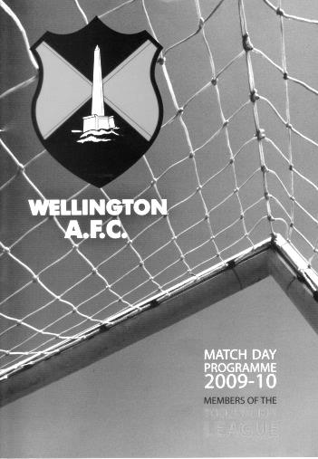
There were happier memories just 6 years ago today as we progressed to the Fourth Round of the F.A. Vase following a wild and windy 3-2 win at Somerset club AFC Wellington. There was doubt about the game going ahead but we travelled down by coach on the Friday evening and all spent the night at a Motorway services Travelodge on the M5!

Fortunately, the game went ahead and we raced into a two goal lead against the very strong wind. This would be easy, we thought, but almost as soon as we thought it, they had reduced the lead with their only attack.

At 2-1 up and with the wind behind us I still thought we’d be ok but a strange looping back header dropped over Paul Borg with minutes remaining. Our keeper then conceded a penalty in the final minute but redeemed himself with a save and in extra time current Assistant Manager Matt Smith was cut down right on the edge of the box but was in full flight and landed well inside it.

A penalty was awarded and Kyle Hough scored his second spot kick of the day to put us through and ensure lots of singing on the coach on the way back, largely guided by Ben Ward, who hadn’t even got onto the pitch! A great adventure!

Combined Counties League Premier Division Opponents
All-time Records
incl Saturday 28th November | P | W | D | L | F | A | PPG | GD | Best  Win | Worst  Loss
Spelthorne Sports* | 4 | 3 | 1 | 0 | 13 | 5 | 2.50 | +8 | 6-2 | -
Sutton Common Rovers | 9 | 7 | 1 | 1 | 24 | 11 | 2.44 | +13 | 4-0 | 1-4
Horley Town | 26 | 19 | 4 | 3 | 57 | 24 | 2.35 | +33 | 6-0 | 1-3
Westfield | 17 | 11 | 3 | 3 | 39 | 27 | 2.12 | +12 | 6-1 | 0-4
Colliers Wood United | 21 | 14 | 2 | 5 | 45 | 28 | 2.10 | +14 | 4-0 | 0-3
Knaphill | 5 | 3 | 1 | 1 | 10 | 6 | 2.00 | +4 | 4-1 | 1-2
Bedfont Sports | 8 | 4 | 2 | 2 | 12 | 10 | 1.75 | +2 | 3-0 | 0-4
Farnham Town | 12 | 6 | 2 | 4 | 21 | 21 | 1.67 | 0 | 3-1 | 1-4
Raynes Park Vale | 25 | 12 | 5 | 8 | 54 | 36 | 1.64 | +18 | 6-1 | 0-2
Hanworth Villa | 13 | 6 | 3 | 4 | 31 | 22 | 1.62 | +9 | 5-0 | 1-4
Hartley Wintney | 9 | 4 | 3 | 2 | 25 | 16 | 1.60 | +9 | 5-0 | 2-4
Guildford City | 14 | 7 | 1 | 6 | 23 | 21 | 1.57 | -5 | 4-0 | 1-5
Camberley Town* | 86 | 38 | 20 | 27 | 155 | 119 | 1.56 | +36 | 9-1 | 0-4
Chessington & Hook | 27 | 11 | 9 | 7 | 52 | 41 | 1.56 | +11 | 6-0 | 1-3
Cove | 33 | 14 | 9 | 10 | 74 | 55 | 1.55 | +19 | 7-0 | 1-6
Windsor | 46 | 18 | 12 | 16 | 86 | 86 | 1.43 | 0 | 4-0 | 0-6
Redhill | 32 | 13 | 2 | 17 | 60 | 69 | 1.28 | -9 | 7-2 | 2-8
Badshot Lea | 15 | 5 | 3 | 7 | 26 | 32 | 1.20 | -6 | 3-0 | 0-4
Chertsey Town | 46 | 16 | 5 | 25 | 65 | 83 | 1.15 | -18 | 3-0 | 0-7
Ashford Town (Mx) | 16 | 4 | 2 | 10 | 22 | 41 | 0.88 | -19 | 3-0 | 0-5
AFC Hayes | 7 | 1 | 2 | 4 | 9 | 15 | 0.71 | -6 | 3-1 | 0-3
Grand Total | 476 | 220 | 91 | 164 | 896 | 772 | 1.58 | 124 | - | -
* includes one abandoned match v Camberley and one loss on penalties v Spelthorne
Looking Up
Ryman League Division One South Table
up to date | P | W | D | L | F | A | Pts | GD
Folkestone Invicta | 22 | 16 | 3 | 3 | 45 | 18 | 51 | +27
Worthing | 23 | 15 | 2 | 6 | 52 | 32 | 47 | +20
Ramsgate | 25 | 13 | 6 | 6 | 47 | 35 | 45 | +12
Dorking Wanderers | 22 | 12 | 5 | 5 | 45 | 25 | 41 | +20
Faversham Town | 24 | 12 | 5 | 7 | 34 | 21 | 41 | +13
Carshalton Athletic | 24 | 13 | 2 | 9 | 40 | 36 | 41 | +4
Herne Bay | 21 | 11 | 6 | 4 | 39 | 21 | 39 | +18
Guernsey | 24 | 12 | 3 | 9 | 48 | 43 | 39 | +5
Molesey | 22 | 12 | 2 | 8 | 46 | 36 | 38 | +10
Corinthian-Casuals | 22 | 11 | 2 | 9 | 31 | 28 | 35 | +3
Three Bridges | 23 | 11 | 2 | 10 | 32 | 31 | 35 | +1
South Park | 21 | 11 | 2 | 8 | 31 | 30 | 35 | +1
Whyteleafe | 24 | 11 | 2 | 11 | 33 | 36 | 35 | -3
Hastings United | 17 | 11 | 0 | 6 | 35 | 20 | 33 | +15
Hythe Town | 21 | 8 | 5 | 8 | 24 | 23 | 29 | 1
Walton Casuals | 24 | 8 | 3 | 13 | 40 | 47 | 27 | -7
Walton & Hersham | 22 | 8 | 3 | 11 | 30 | 40 | 27 | -10
Tooting & Mitcham United | 22 | 8 | 2 | 12 | 25 | 35 | 26 | -10
Chatham Town | 23 | 7 | 4 | 12 | 33 | 31 | 25 | +2
East Grinstead Town | 21 | 6 | 5 | 10 | 28 | 38 | 23 | -10
Peacehaven & Telscombe | 24 | 6 | 5 | 13 | 28 | 49 | 23 | -21
Sittingbourne | 20 | 6 | 0 | 14 | 24 | 38 | 18 | -14
Chipstead | 23 | 3 | 2 | 18 | 22 | 56 | 11 | -34
Whitstable Town | 24 | 2 | 1 | 21 | 25 | 68 | 7 | -43
When we last covered this league table, Lyndon Buckwell appeared to be breathing some life into our landlords Chipstead. He had got them winning a few games and taken them off the foot of the table. It was therefore something of a surprise to see them dispense with his services in the middle of November! However, new Manager syndrome appears to be alive and well at a higher level as they then won 6-1 at Sittingbourne.

It is a surprise to see well supported clubs like the Bourne potentially dropping back into Step Five football, although it happened to Horsham last year so it’s not impossible. If a Kent club drops back down it does at least mean that there is less chance of a transfer into that League for Combined Counties clubs, like ourselves. Actually if things changed and it did turn out that Chipstead were the only club to drop, it begs the question of which league might they go into, and if they are moved to the Southern Counties East League, would that increase our chances of being moved too? A worrying thought! Best to hope that they stay up!

Folkestone Invicta continue to lead the way and have a little breathing space but Worthing are in good form and if they keep it going, could find themselves back up at Step Three for the first time in a while. Or maybe it could be Dorking Wanderers if the Meadowbank ground is completed in time as there is surely no way they could play Step Three football at Westhumble.

Looking Up
Evo-Stik Southern League Central Division Table
up to date | P | W | D | L | F | A | Pts | GD
St Ives Town | 18 | 11 | 5 | 2 | 31 | 15 | 38 | +16
AFC Rushden & Diamonds | 16 | 11 | 4 | 1 | 39 | 15 | 37 | +24
Chalfont St Peter | 18 | 12 | 1 | 5 | 40 | 23 | 37 | +17
Royston Town | 18 | 10 | 3 | 5 | 39 | 20 | 33 | +19
Ware | 19 | 10 | 3 | 6 | 33 | 29 | 33 | +4
Beaconsfield SYCOB | 20 | 9 | 5 | 6 | 38 | 25 | 32 | +13
Egham Town | 17 | 10 | 1 | 6 | 37 | 15 | 31 | +22
Aylesbury | 18 | 9 | 4 | 5 | 30 | 17 | 31 | +13
Kings Langley | 17 | 10 | 1 | 6 | 32 | 21 | 31 | +11
Northwood | 17 | 9 | 2 | 6 | 27 | 21 | 29 | +6
Uxbridge | 18 | 7 | 4 | 7 | 29 | 30 | 25 | -1
Potters Bar Town | 17 | 7 | 2 | 8 | 22 | 27 | 23 | -5
Arlesey Town | 20 | 7 | 2 | 11 | 25 | 41 | 23 | -16
Bedford Town | 17 | 6 | 4 | 7 | 25 | 26 | 22 | -1
Barton Rovers | 19 | 5 | 7 | 7 | 30 | 32 | 22 | -2
Petersfield Town | 18 | 5 | 5 | 8 | 29 | 35 | 20 | -6
Godalming Town | 17 | 5 | 4 | 8 | 18 | 24 | 19 | -6
Fleet Town | 19 | 5 | 3 | 11 | 26 | 50 | 18 | -24
Hanwell Town | 17 | 4 | 4 | 9 | 16 | 27 | 16 | -11
Aylesbury United | 19 | 4 | 3 | 12 | 23 | 46 | 15 | -23
Leighton Town | 19 | 3 | 3 | 13 | 17 | 45 | 12 | -28
North Greenford United | 16 | 2 | 2 | 12 | 21 | 43 | 8 | -22
Seeing as Guildford City are our opponents this afternoon it makes sense to include this table too, as they originally went up into this division last time, instead of the Ryman South that we would be moved into if we were ever to gain promotion.

Last month I tipped the teams to watch as AFC Rushden & Diamonds and Egham Town and both are still well placed and with games in hand. At the bottom, they may have games in hand but North Greenford United are in trouble yet again, having escaped narrowly in the previous two seasons. They also had a tragic event to deal with last week when a supporter collapsed and died at their home game with Bedford Town which was then abandoned.

Just above them we see Aylesbury United and Leighton Town, both of whom currently play at Bell Close, the latter’s home. Aylesbury are in a similar situation to ourselves, although they have actually lost two grounds in the last thirty years and although Turnfurlong Lane is long since covered by housing, Buckingham Road still lies vacant and derelict, due to a breakdown in relations with the owners of the ground. With their cross town neighbours Aylesbury F.C. managing comfortably in this division and in their own ground it makes you wonder how long the Ducks can continue and whether they are now just trading on their own name and history.

Looking Down
Combined Counties League Division One Table
up to date | P | W | D | L | F | A | Pts | GD
CB Hounslow United | 15 | 12 | 2 | 1 | 35 | 9 | 38 | +26
Worcester Park | 16 | 11 | 2 | 3 | 43 | 17 | 35 | +26
Eversley & California | 15 | 11 | 1 | 3 | 46 | 22 | 34 | +24
Bedfont & Feltham | 12 | 9 | 1 | 2 | 37 | 15 | 28 | +22
Abbey Rangers | 15 | 9 | 1 | 5 | 25 | 17 | 28 | +8
Staines Lammas | 16 | 8 | 1 | 7 | 34 | 27 | 25 | +7
Cobham | 16 | 7 | 2 | 7 | 34 | 37 | 23 | -3
Frimley Green | 12 | 6 | 2 | 4 | 19 | 15 | 20 | +4
Dorking | 14 | 6 | 0 | 8 | 23 | 22 | 18 | +1
Sandhurst Town | 14 | 5 | 2 | 7 | 28 | 41 | 17 | -13
Ash United | 14 | 4 | 3 | 7 | 24 | 30 | 15 | -6
Banstead Athletic | 11 | 4 | 2 | 5 | 21 | 23 | 14 | -2
Epsom Athletic | 14 | 4 | 1 | 9 | 23 | 41 | 13 | -18
Dorking Wanderers Res | 14 | 3 | 3 | 8 | 14 | 24 | 12 | -10
Sheerwater | 13 | 3 | 1 | 9 | 21 | 32 | 10 | -11
Farleigh Rovers | 13 | 2 | 1 | 10 | 10 | 43 | 7 | -33
South Park Reserves | 12 | 1 | 1 | 10 | 13 | 35 | 4 | -22
A number of fixtures have been played since we last looked at this table but the situation is largely as it was; with the top three as they were and with Bedfont & Feltham close behind the leaders, although with games in hand. They no longer hold an unbeaten record but still look the most likely to catch the top three than anyone.

Having said all that, Abbey Rangers can’t yet be discounted either. They won 3-0 at Eversley & California on Saturday and although they have a few points to make up, they are clearly settling in at this level now, having had a decent run in the F.A. Vase too. It wouldn’t surprise me if they finished in the top three.

Of course you can’t look at the top clubs without wondering about ground grading. Are Abbey Rangers able to host Step Five football yet? Will Worcester Park be relegated this year instead of promoted, and what will happen to Staines Lammas who terminated their ground share at Ashford this season but their ground is lacking in floodlights. What will happen at the end of the season? It’s anyone’s guess really!

At the other end it is interesting to see the two newly introduced Reserve teams struggling. Many felt that these teams would be blocking promotion places, so much so that the league introduced a rule ensuring that a club as low as fifth could be promoted this season, should both Reserve sides finish above them, but it just shows that the standard of Reserve team football is maybe not quite as good as first thought.

From behind the goal
Bedfont Sports 2-2 Epsom & Ewell
Combined Counties League Premier Division - Tuesday 24th November 2015

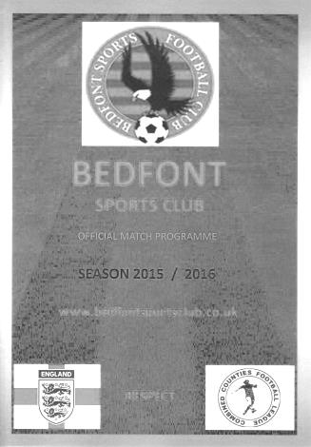
Late equaliser rescues a point but doesn't tell the story

We travelled to the Bedfont Sports Club, expecting, and getting a thoroughly competitive contest between two sides who wanted to play football on a great surface. It was therefore a great pity that large portions of the game were ruined by a number of poor, incorrect and at times downright suspicious decisions, with our boys being on the receiving end of most of them.

We named an unchanged eleven following our win over Hanworth Villa with Kyle Hough and Dan Dean both on the bench once again. After an unexplained seven minute delay, the game started well for us and the opening 15 minutes of the match was generally played in the opposition half, with exception of a break on the left wing that resulted in a cut in and shot that Michael Eacott dealt with comfortably at his near post.

At the other end Josh Richardson the Bedfont Sports keeper was certainly more involved in the play and tipped over a left footed drive from Daryl Cooper-Smith from the edge of the area and was nearly embarrassed by a forty yard effort from the same player that hit the bar and bounced over for a goal kick after 22 minutes. Moments later the home defender Adam Fearn picked up a yellow card for a blatant handball on the edge of the area and Matt Ferdinando bent his shot around the wall but Richardson got a strong hand on the ball to push it away at full stretch.

A few minutes later our right winger Reisse Griffin also picked up a yellow card for complaining about the non-award of a free kick. To be fair he had been fouled on three occasions in the previous five minutes, yet none had been awarded and he would be fouled later in the match with more serious consequences. Our Manager also wanted to let his feelings be known at this point as a number of challenges by both sides went unpunished. These things almost always come back at the official later on as players try to deal with matters themselves in the knowledge that they aren't receiving any protection from the people who are supposed to be doing it.

As the half came to an end Matt Farrell had a try from the edge of the box after cutting in on the right but the ball cleared the bar by about 12 inches and Tom Neale got on the end of a long Eacott kick to strike at goal. The effort was well blocked by the defender and the ball looped up, falling kindly for Neale, but from an angle he put his volley just over the bar from just eight yards.

We were ahead on points at half time but it was still level and we knew that the home side had come back into the game as the half had progressed. After 51 minutes Fearn again handballed on the edge of the area, but despite this being a second yellow card had he blown the whistle, the referee appeared to play some sort of advantage, or maybe just chose not to see the offence and we were unable to make anything of it. Fortunately two minutes later we broke through on the left and the ball reached Rob Hendry, and his deep cross was met by a looping header from Cooper-Smith that was just out of the reach of the keeper to open the scoring.

In the 59th minute we won a free kick for a foul. I had to make a note of this as it was only the

second time in the match I could recall us winning one! A few minutes later a Bedfont player took a throw, a long way from the point where it had gone out and our Manager, by now getting very frustrated with the number of decisions against us, was then sent off. This was only the second time in club history that we have had a Manager sent from the dugout and I've not seen Glyn so angry on the sidelines as he had been during this match, which gives you an indication of what was going on out there.

Cooper-Smith picked up a booking for a clumsy challenge that he may not have received had he shown a bit of remorse for the foul, but nearly redeemed himself with a good run and shot that was a yard wide of Richardson's right hand post. In the 76th minute there were two great chances, firstly for the home side as their striker was put clean through but Eacott stood his ground and saved really well, and then on the counter attack Neale was put through with the defenders shouting for offside, which he probably was. However, his attempt was also well saved and the follow up of the loose ball from Hendry came at an awkward height and was scuffed.

Neale was replaced moments later by Hough before Cooper-Smith set up Griffin for a strike that was just beyond the far post but in the 82nd minute the game changed. Rhys North had been replaced by Dean but we became more vulnerable at right back as a result and the home side earned a corner on that side which was met by a decent looking header that cannoned off Matt Tanton, well positioned on the line and the ball was hooked away. Unfortunately the home shouts for a penalty were reinforced by an Assistant that looked so keen to award it, that it looked as though he was trying to wave his flag off, and the penalty and inevitable red card that accompanied it were brandished in his direction. Jamie Read gave Eacott no chance with the penalty after 84 minutes and we were level.

Worse was to come when Griffin ran at the defenders but was brought down from behind. Well, actually, no he wasn't, according to the referee and the long ball into the vacant channel he was then unable to cover was collected by the full back Julius Mngadi who unleashed a great low drive from the corner of the area across Eacott and into the far corner to give Bedfont Sports the lead. They hardly had time to celebrate before we were witnessing an 89th minute equaliser that was admittedly fortunate as Hendry's left wing cross dropped over the keeper and into the far corner.

Relief was everywhere amongst the Epsom players, although there was still anger and Cooper-Smith then received a red card for something he said. Whatever it was, it wasn't loud as I was only ten yards away and didn't hear it, but the referee, maybe fed up of being criticised for having such a poor game, waved a red card at our man, leaving us with nine players. He then made the mistake of going near to the Assistant on the way off the field, where other things were alleged to have happened.

Whilst this cannot be condoned, it was hugely frustrating to put in a huge effort only to be confronted time and time again with a number of errors. I can fully sympathise with our players who were absolutely seething after the match, and although you could argue that if we had taken our chances earlier in the match, then we wouldn't have had such an issue, I'm not convinced. I have no problem with our players getting fouled; it is after all, a part of the game. However, the lack of awareness from the personnel whose first priority surely is to protect them out there was pitiful and as a club suffering a number of injuries right now, it is all the more concerning. This game will be remembered by our players and supporters for many years to come, although not a single discussion about it will be relating to any of the four goals scored, which tells you all you need to know about this one.

Team: Michael Eacott, Rhys North, Matt Tanton, James Taylor, Craig Hastings, Matt Ferdinando, Rob Hendry, Matt Farrell (C), Tom Neale, Daryl Cooper-Smith, Reisse Griffin

Subs: Dan Dean for North (70), Kyle Hough for Neale (77)

From behind the goal
Colliers Wood United 0-3 Epsom & Ewell
Combined Counties League Premier Division - Saturday 28th November 2015

Epsom chop through the Wood in second half

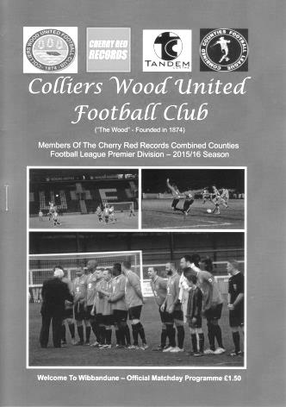
The Salts let their football do the talking as they produced a clinical second half attacking performance to go with a disciplined first half display to come away with a 3-0 win over their in form opponents on their own patch.

Following Tuesday's frustrating outing at Bedfont Sports, Assistant Manager Matt Smith, taking charge in Glyn Mandeville's absence, made three changes with Adrian Jones coming in for the working Michael Eacott, Kyle Hough starting the match at the expense of Tom Neale and the fit again Alex McKay returning to the midfield, moving Matt Ferdinando back out to the right wing in place of Reisse Griffin who was getting married! We had an unfortunate start in just the second minute as James Taylor made a solid block tackle to break up an early home attack but injured himself in the process. He returned after treatment but would only manage another twenty minutes before we had to make a substitution.

The opening twenty minutes were mostly played in our half as we struggled at first to deal with the power and pace of Colliers Wood's dangerous attacking trio of Mario Embalo, Dan Harding and Eli Ogunseye although things improved after Taylor was replaced by the returning Carl Downs with the fit again McKay dropping back into the back four. Clearly Taylor's injury had hampered him and we looked less vulnerable from that point, despite McKay's early booking for a clumsy challenge. For Downs, it looked as if he had never been away as he slotted straight in, showing no signs of any perceived lack of match fitness there may have been.

We had only created one half chance by that point when a Rob Hendry left wing cross eluded Wester Young, and was collected at the far post by Ferdinando but his cross back into the danger area was easily cleared. In fact it took us until the 32nd minute to create a good chance when Hough's shot from an angle was well saved by Young. As we began to get more into the match, we nearly got caught as a strong left wing run and pull back found Embalo in space but his low shot from ten yards out lacked power and Jones was able to make a great block with his trailing leg. They didn't know it then, but this would be their last real chance in the match.

In fact we also had a chance to take the lead just before half time when a deep ball was headed into Hough's path by Ferdinando and although he drew the keeper over, his shot from 15 yards was too close to him and he also used his legs to make a save.

That would have been harsh on the home team to that point but the second half would prove to be a different story. The first thing I noted at the start of the half was that it was actually a lot windier than I had thought, having stood behind the sheltered "A3 end" in the first half. We were to use that to our advantage and nearly took the lead when a Ferdinando free kick from out on the touchline moved in the air and just eluded a couple of our players as it whizzed through and out for a goal kick.

A strange incident occurred in the 55th minute when a ball over the top of the defence was chased down by Matt Farrell, revelling in his role as Captain, and he appeared to get ahead of his opponents before going down. It was hard to say whether he was fouled or not, but Hough collected the ball and cut inside the keeper to score before his "goal" was then disallowed, incredibly for offside. I cannot understand how anybody could at any point have been offside and there were a couple of other odd offside decisions later on. We didn't deal well with the injustice we faced on Tuesday so it was to our boys credit that they just got on with it this time, despite their disappointment.

We made a switch in the 63rd minute as Neale came on for Hendry and it worked almost immediately as two minutes later a ball in from the left was contested in the air by former Salt Jon Boswell and Ferdinando. I half expected a whistle to be blown against our man as Boswell didn't get the ball clear but as it fell, Cooper-Smith swivelled and swept the ball in from twelve yards on the half volley, giving the keeper no chance.

Within a minute it was virtually game over. A clumsy handball on the area gave Ferdinando the opportunity to strike at goal and he bent the ball low around the wall and towards the far corner. Young did well to make the save but couldn't hold it and as three of our players rushed in it was Hough who got there first, poking the ball over the prostrate keeper and into the net from close range for our second goal.

Neale tried his luck from 25 yards and wasn't far away before we were forced into a further reshuffle when Rhys North had to come off with fifteen minutes remaining, so Ferdinando went to right back as Beckett Oliver came on. By now though the home team were well beaten and we nearly scored a third when Neale chased down a defender, won the ball off him and ran at goal but in chipping the advancing Young, he sliced his shot at the crucial moment and the ball went out for a goal kick.

There was just time for Jones to make an impressive and acrobatic one handed "NFL style" catch of a deep left wing cross, which was an important intervention as a striker was waiting in space for the cross. As we went into injury time Cooper-Smith put a gloss on the scoreline with a superb chip from twenty-five yards with his weaker left foot, over the keeper and just under the bar. I love standing behind the goal at times like this when you know the ball is going to come down just in time, and it was great to get back to winning ways away from home after three consecutive away league draws.

Overall this was a very clinical performance, both in attack and defence, and right now we are showing signs of being in this title race for the long haul. I hope so!

Team: Adrian Jones, Rhys North, Matt Tanton, James Taylor, Craig Hastings, Alex McKay,
Rob Hendry, Matt Farrell (C), Kyle Hough, Daryl Cooper-Smith, Matt Ferdinando

Subs: Carl Downs for Taylor (23), Tom Neale for Hendry (63), Beckett Oliver for North (77)

CCL Premier Division Club Directory
A.F.C. HAYES Telephone: 0208-845-0110 - Ground: Farm Park, Kingshill Avenue, Hayes, Middx. UB4 8DD - Colours: Blue and White Stripes/Blue/Blue

ASHFORD TOWN (Mx) Telephone: 01784-245908 - Ground: The Robert Parker Stadium, Short Lane, Stanwell, Middx. TW19 7BH - Colours: Tangerine & White Stripes/Black/Tangerine

BADSHOT LEA Telephone: 01252-320385 - Ground: Ash United FC, Shawfield Stadium, Youngs Drive, Shawfields Road, Ash, Hampshire. GU12 6RE - Colours: Claret/White/Claret

BEDFONT SPORTS Telephone: 0208-831-9067 - Ground: Bedfont Sports Club, Hatton Road, Bedfont, Middx TW14 8JA - Colours: Red & Black Hoops/Black/Red & Black Hoops

CAMBERLEY TOWN Telephone: 01276-65392 - Ground: Krooner Park, Wilton Road, Camberley, Surrey. GU15 2QW - Colours: Red & White Stripes/Blue/Red

CHERTSEY TOWN Telephone: 01932-561774 - Ground: Alwyns Lane, Chertsey, Surrey. KT16 9DW - Colours: Royal Blue & White Stripes/Royal Blue/Royal Blue

CHESSINGTON & HOOK UNITED Telephone: 01372-602263 - Ground: Chalky Lane, Chessington, Surrey. KT9 2NF - Colours: Blue/Blue/Blue

COLLIERS WOOD UNITED Telephone: 0208-942 8062 - Ground: Wibbandune Sports Ground, Robin Hood Way, Wimbledon. SW20 0AA - Colours: Blue & Black Stripes/Black/Black

COVE Telephone: 01252-543615 - Ground: Oak Farm Fields, 7 Squirrel Lane, Cove, Farnborough, Hampshire. GU14 8PB - Colours: Yellow/Black/Yellow

EPSOM & EWELL Telephone: 01737-553250 - Ground: Chipstead FC, High Road, Chipstead, Surrey. CR5 3SF - Colours: Royal Blue & White Hoops/Royal Blue/Royal Blue & White Hoops

FARNHAM TOWN Telephone: 01252-715305 Ground: Memorial Ground, Babbs Mead, West Street, Farnham, Surrey. GU9 7DY Colours: - Claret & Sky Blue /White/ Claret & Sky Blue

GUILDFORD CITY Telephone: 01483-443322 - Ground: The Spectrum, Parkway, Guildford, Surrey. GU1 1UP - Colours: Red & White Stripes/Black/Black

HANWORTH VILLA Telephone: 0208-831-9391 - Ground: Rectory Meadows, Park Road, off Hounslow Road, Hanworth, Middlesex. TW13 6PN - Colours: Red & White Stripes/Black/Black

HARTLEY WINTNEY Telephone: 01252-843586 - Ground: Memorial Playing Fields, Green Lane, Hartley Wintney, Hants RG27 8DL - Colours: Orange & Black/ Orange /Orange

HORLEY TOWN Telephone: 01293-822000 - Ground: The New Defence, Anderson Way, Court Lodge Road, Horley, Surrey. RH6 8SP - Colours: Claret & Sky Blue/Claret/Claret

KNAPHILL Telephone: 01483-475150 - Ground: Brookwood Country Park, Redding Way, Lower Guildford Road, Knaphill, Surrey. GU21 2AY - Colours: Red/Black/Red

SUTTON COMMON ROVERS Telephone: 01932-866386 - Ground: Sutton United FC, Gander Green Lane, Sutton, Surrey SM1 2EY - Colours: Yellow/Black/Black

RAYNES PARK VALE Telephone: 020-8540-8843 - Ground: Prince Georges Playing Field, Grand Drive, Raynes Park, London. SW20 9NB - Colours: Blue/Blue/Red

REDHILL Telephone: 01737-762129 - Ground: Kiln Brow, Three Arch Road, Redhill, Surrey RH1 5AG - Colours: Red and White Stripes/Black/Red

SPELTHORNE SPORTS Telephone: 01932-961055 - Ground: Spelthorne Sports Club, 296 Staines Road, Ashford Common, Ashford, Middx. TW15 1RY - Colours: Light & Dark Blue/Dark Blue/Light Blue

WESTFIELD Telephone: 01483-771106 - Ground: Woking Park, Kingfield Road, Woking, Surrey. GU22 9BA - Colours: Yellow/Black/Black

WINDSOR Telephone: 01753-860656 - Ground: Stag Meadow, St Leonards Road, Windsor, Berks SL4 3DR - Colours: Red/Red/Red

EL Records Premier Challenge Cup
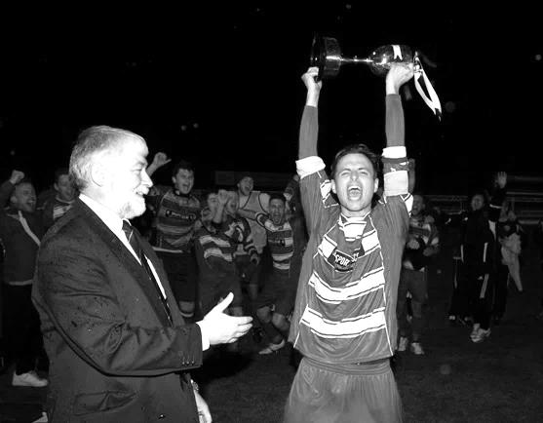
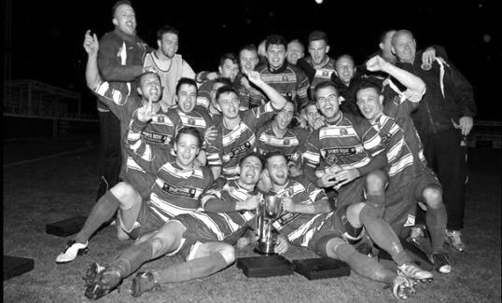
Second Round
Dorking Wanderers | 2-1 | South Park Reserves
Westfield | 1-0 | CB Hounslow United
Bedfont & Feltham | 1-5 | Colliers Wood United
Dorking | 0-3 | Knaphill
Badshot Lea | 2-4 | Spelthorne Sports
Hanworth Villa | 1-2+ | Chertsey Town
Ashford Town (Mx) | 2-1 | Epsom Athletic
Hartley Wintney | 4-2 | Horley Town
Banstead Athletic | 1-1+ | Epsom & Ewell
Epsom & Ewell won 7-6 on penalties
Sheerwater | 3-3+ | Frimley Green
Frimley Green won 8-7 on penalties
Farnham Town | 3-2 | Abbey Rangers
Camberley Town | 4-2 | Eversley & California
AFC Hayes | 0-1 | Banstead Athletic
Redhill | 3-0 | Sutton Common Rovers
Worcester Park | 1-5 | Chessington & Hook United
Cove | 1-6 | Cobham
Third Round
Camberley Town | 15/12 | Spelthorne Sports
Cobham | 15/12 | Frimley Green
Redhill | 15/12 | Farnham Town
Raynes Park Vale | 15/12 | Westfield
Epsom & Ewell | 12/1 | Ashford Town (Mx)
Colliers Wood United | 16/12 | Dorking Wanderers Reserves
Knaphill | 15/12 | Chertsey Town
Hartley Wintney | 15/12 | Chessington & Hook United

Every Opponent A-Z
Over the years we have played many, many different opponents. Exactly how many is a difficult question, as it all depends on your definition. Are Camberley & Yorktown different to Camberley Town, or are Epsom Town different to Epsom F.C. or Epsom & Ewell F.C.?

In my analysis I have classed them as the same team, and will work through them all from A to Z. Some we have played many times, whilst others we have met just once or twice. Enjoy!


Reading Town: Played 4 - W0 D0 L4 - F0 A8 - PPG - 0.00

Scours Lane is not a particularly happy venue for us. Come to think of it, Reading Town are the team with whom we have our worst record against, with four losses out of four and not even a goal to write home about!

Our first meeting was on the opening day of the 2006/07 season; our first since transferring from the Ryman League to the Combined Counties and we were edged out by a goal to nil. Regrettably, this was about as good as it got and they completed the double by the same score in the return in Reading in January.

We returned for another go in the September but once again fell one-nil before having a bit of a mare in the home return on 5th January 2008 and being thrashed 5-0, although that match was 1-0 for quite a while too.

At the end of the 2007/08 season they swapped leagues with Badshot Lea and now compete in the Hellenic League, which was a relief to us, although it should be remembered that our record against the Lea isn’t that much better!

Redhill: Held over to next issue

Reigate Priory: Played 9 - W9 D0 L0 - F60 A7 - PPG - 3.00 - Perfect

From worst to first as we move from the club we have the worst record against to the club with whom we have our best record!

Reigate Priory are the oldest football club in Surrey and were already well established by the time one of our forerunners, Ewell F.C. came into existence way back in 1890. By the time Epsom Town met the Priory for the first time, they had been surpassed by many clubs and were quite weak.

Although we became a Senior status club in 1924 they weren’t in the Surrey Senior League that year, joining it in1925. We were just moving in at West Street and were about to take local football by storm, heading for two consecutive Surrey Senior League titles and a Cup win. Better teams than theirs never stood a chance against us, and they were crushed 8-0 on Boxing Day 1925 with Reg Marlow scoring four times, although we had a narrower squeak against them in the return on the Easter Monday and only won 2-1, despite the match being switched to West Street because of cricket at their Park Lane ground. Marlow only got the two that day but in total would tally 14 goals in his five appearances against them!

Our next meetings were just a week apart in the February of the 1926/27 season when we defeated them 7-2 in the League Charity Cup and then 7-0 seven days later in the League with both matches being home ones. However, we weren’t fussy and in April 1927 we won the return league match 7-2 on their own patch on a Monday evening!

That was the last time we ever met as League equals, with our next two meetings being Amateur Cup ties. The first of these was in October 1927 with us by now trying out the London League for

size so we were arguably a stronger side still by this time and true enough we won 7-1 at West Street with Freddie Behn scoring a hat trick; his second against Priory having got his first in the Cup tie earlier that year. In that calendar year of 1927 we played them four times, scoring seven on each occasion!

We didn’t meet for another eight years until we were paired together for another Amateur Cup tie. By now they were playing in the Amateur Leagues while we were still a decent London League outfit. Oddly enough this would prove to be our worst pre-war season with a tenth place finish, having only once before finished outside the top five.

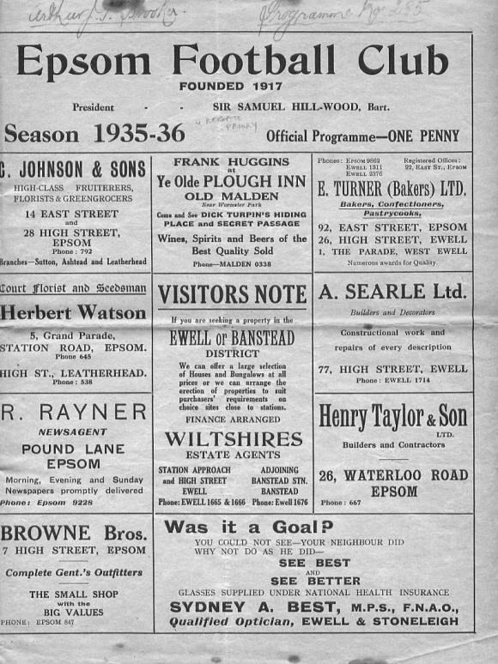
But it didn’t matter as we racked up six goals in the first half alone and added seven more in the second half for a club record victory of 13-1 that still stands to this day. (see programme pictured)

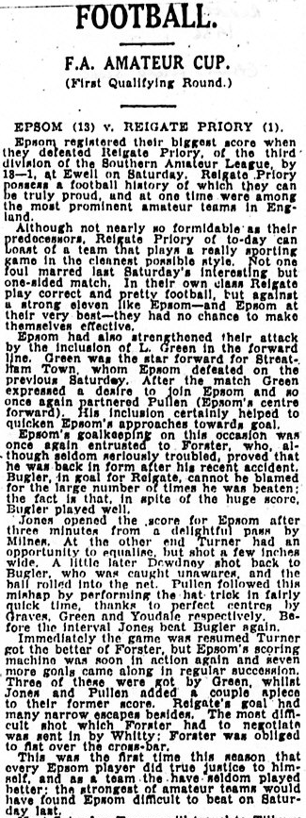
The Epsom Herald called it a slaughter of the innocents although I have included the Epsom Advertiser report here as it fits better on the page!

We met on two further occasions; on 17th October 1970 in a Surrey Senior Cup tie. We hadn’t won all year, and were truly dreadful yet still won 5-0, before our final meeting on 26th October 1974 which long term supporters will remember was the very first match we played on our F.A. Vase run to Wembley. Considering the side we had that season, it is somewhat surprising that we only won 4-0! They still exist to this day, and remain at the same venue hidden away off of the High Street.

Centre page for results

Centre page for results



Guildford City – History
The first club in the town was amateur side Guildford FC, formed in 1877, and known as the “Pinks”. They played home matches at the Woodbridge Road Sports Ground. A successful start led to a number of people mooting a new professional club and by the end of 1920 Guildford United was formed. In May 1921 they were accepted into the Southern League, the equivalent of the Conference League today. At the same time land had been purchased in Joseph’s Road and “United” were able to kick-off the 1921-22 season with a home game against Reading Reserves. Playing in green and white the hosts won 2-0 with a crowd of over 5,000 spectators.

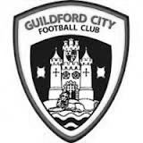
1927 saw the coming of Guildford as a Diocese and with it the building of a Cathedral. It was believed that Guildford would become a city so the Club changed its name and the “City” was born. At this time they also changed the colours to red and white stripes.

Although they had little early success in the League, the FA Cup bought a taste of glory in 1928-29 when, having battled through the qualifying rounds, they beat Queens Park Rangers 4-2 in the First Round Proper in front of a crowd of nearly 8,000. In the next round they were at home to Bournemouth but a similar crowd saw the visitors romp home 5-1.

Despite excellent gates and the highest League finish to date the Club was facing a financial crisis at the end of the season – this was to be a recurrent theme throughout the Club’s history. At the start of the 1936/37 season the Club made the massive decision to turn full-time professional, appointing Haydn Green as manager. That season they finished 4th but next season things got even better.

1937/38 saw victory over Reading in the FA Cup but in the League they won 22 of their 34 games to finish as Champions for the first time. That feat was nearly repeated the following year, with City finishing runners-up to Colchester United by 1 point, scoring 126 goals in the process. Indeed the League game at home to Colchester on Easter Monday saw City win 3-1 in front of the highest crowd ever for a League game at Joseph’s Road 9,443. Earlier that season City had attracted an even bigger crowd to Joseph’s Road for an FA Cup 1st Round Replay against local rivals Aldershot. 9,932 saw City lose a nail-biting game 4-3.

This successful period was brought to a premature conclusion by the outbreak of the Second World War. The ground had been used by the Army during the War and it wasn’t until 1946/47 that City re-entered the Southern League – this time as a part-time club. They again finished runners-up, this time to Gillingham but there followed 3 seasons of mediocrity. In 1950/51 the team finished 3rd in the League and reached the final of the Southern League Cup for the first time, losing to Merthyr Tydfil despite winning the first leg.

The 1951/52 season saw the longest trip ever undertaken by the City when they were drawn away to Gateshead in the 2nd Round of the FA Cup. An estimated 5,000 supporters made the overnight trip to the North East of England in December (there were no motorways in those days, and no heaters on coaches either!). A 15,000 crowd saw City dominate the game but lose 2-0. In debt again, City sold Jimmy Langley to Leeds for £2,000 – who eventually joined Fulham and earned three England international caps.

Archie Macaulay was brought in as player-manager in 1953 and he started building a side that would win the title in 1955/56. However, he left before the end of the season leaving Bill Thompson to take over and lead the side to the championship. In 1958/59 the League expanded and was regionalised. City were in the South Eastern zone and could only finish 15th out of 17.

For 1959 the League was revised again, this time to a Premier and First Division. City’s miserable time the year before meant they started in the lower division. Albert Tennant, who had been a coach at Chelsea, took charge and he led City to promotion. After a season of consolidation, the next four seasons saw finishes of 3rd, 4th, 4th and 2nd: on the last occasion only 2 points behind champions Weymouth. In the

1962/63 season they also lifted the Southern League Cup for the first time, beating Nuneaton Borough 2-1 on aggregate over two legs.

Despite this success by the summer of 1965 it seemed that finance was again a major problem at the Club. A strict budget left the club short of players, resulting in a disappointing 16th place finish, although they did manage to reach the final of the Southern League Cup again. They went on better the next year, winning the Southern League Cup with a 2-1 aggregate success over Barnet.

1967/68 saw a notable FA Cup run. Drawn away to Brentford the City were leading 2-1 when the match was abandoned during the second half because of snow. A second trip to Griffin Park ended with a 2-2 draw and meant a replay at Joseph’s Road in front of 7,500 fans who roared City to a famous 2-1 victory. Goalkeeper Peter Vasper was sold to Norwich City for £5000 and it was thought that this money and the money from the Cup games might ease the Club’s financial problems but they were worse than many had realised. The following season saw the end of Albert Tennant’s nine year reign and the Club was relegated.

In 1969/70 Joseph’s Road was sold to signal the beginning of the end for the Club. The following year they reached the second round of the FA Cup but the inevitable was only being delayed and although in 1972/73 the Club again reached the first round of the FA Cup (a visit to Watford ended with a 4-2 defeat), they could only finish 18th in the League. Crowds of 4,000 were needed to break even but barely a quarter of that was achieved at most games.

Guildford City Football Club Shock End Surrey Advertiser1973/74 saw a new board of directors in place with Bill Bellerby elected President (recently elected as Patron of the new club) and Club stalwart Darby Watts as player manager. Despite the best efforts of Mr Bellerby and the long standing Chairman of the Supporters’ Club John Daborn, it was soon announced that the Club was to merge with Dorking and play at Meadowbank. The final game at Joseph’s Road was played on 12th February 1974 when the City beat Folkestone 2-0 in front of 625 fans. After 53 years senior football at Joseph’s Road had come to an end.

In 1996 Bill Bellerby, then Mayor of Guildford, enquired as to whether Burpham FC would be prepared to move to the Spectrum Leisure Centre and represent Guildford. Spectrum provided a venue which had the potential for development into senior football and already had floodlighting.

Guildford City Football Club 2004 League Champions AFC Guildford played in the Surrey Premier League, which eventually became Division One of the Combined Counties League. In 2003/04 AFC Guildford were crowned champions of Division One and gained their first ever major honour.

Promotion was obtained into the Combined Counties Premier Division, ground-sharing with Cranleigh FC while Spectrum was upgraded to an acceptable standard. In early November 2004, AFC Guildford returned to their home ground near to the town centre.

After a 12 month period as Guildford United, the club was re-named the historically significant ‘Guildford City’, after an absence of thirty years. 2007-2008 saw City claim a runner up finish in the Combined Counties Premier League, under the management of Scott Steele and Lloyd Wye. Then saw a period of struggle which was only alleviated by the inspirational appointment of Kevin Rayner, and his assistant Roly Martin, who took charge in spring 2009.

Their first full season at City saw a much improved seventh place finish in 2009-10. The following year saw a good run in the FA Vase, an incredible FA Cup victory at Ryman Premier Tonbridge Angels, but also the Combined Counties Premier Division Championship.

A second Combined Counties Championship was gained in 2012, resulting in an emotional return to the Southern League after a gap of 38 years.

Change was on the way after a creditable ninth place finish in the Central division. At the conclusion of 2012-13 Rayner departed for a new chapter in his career. However in November 2013 he returned to the Spectrum to lead an ultimately unsuccessful battle against relegation from the Southern League.

After a poor start to the 2014-15 Combined Counties League season, Kevin Rayner departed in November to be replaced by local coach Donovan Chislett who ultimately saved the club from relegation in an exciting climax to the season. Donovan himself departed in September 2015 to be replaced by former Godalming & Farncombe Athletic FC manager Dean Thomas who leads the club into the future.

Guildford City – Player Profiles
Dean Thomas (Manager): Took over the reigns as manager at City in September 2015. He was formerly manager of Surrey Elite League side Godalming & Farncombe Athletic where he had steered that club to their three most successful seasons. He played for Aldershot Town U’18’s and Godalming & Farncombe before injury cut short his playing career.

Mark Beach (Goalkeeper Coach): Formerly coached at Staines Lammas and Guildford Saints Junior clubs and in more recent years has assisted with Walton & Hersham U’18s.

Matt Anton: A former West Ham United YTS striker who has been a prolific goal scorer in intermediate football. He joins us from Surrey Elite League side Godalming & Farncombe Athletic.

Liam Beach: A former Guildford Saints Juniors goalkeeper who has been a revelation since making his debut against Windsor at Christmas 2014. Still only 17, Liam was Young Player of the Year in 2014-15.

Sanchez Benali: An energetic and skilful midfield player who signed for City from lower league football. He originally was a junior at QPR.

Aiden Bigley: A midfielder who originally played as a junior for Garston Boys in Hertfordshire. Now plays representative football in HM Forces. Signed for City in October 2015.

Tom Booth: A right sided player who is comfortable at full back or in midfield. His former club is Godalming & Farncombe Athletic. He scored for City on his debut against Raynes Park.

Darren Caesar: A hard working midfield player who has joined the club from Egham Town. His other clubs include Farnborough Town and Colliers Wood United for whom he played in last season’s FA Vase run.

Nathan Chambers: A young striker with searing pace initially signed on dual registration from Farnborough Town. He spent much of his youth in France where he came through the AJ Auxerre and AS Cannes academy set ups.

Jack Collins: A former QPR and Woking Academy captain who is comfortable playing in defence, midfield and attack! He joined City from intermediate side Chobham Burymead and was City’s Manager’s Player of the Year in 2014-15. Club Captain for 2015-16.

Rory Cornelius: A member of last season’s Youth side and who made his debut at Frimley Green in March 2015. He impressed so much that he refused to let go of his place in the team! A midfield player, he is currently studying at Leicester University.

James Davies: An experienced full-back who signed in October 2015 from Godalming & Farncombe Athletic. He also plays representative football in the military.

Harry Driver: A longstanding former Ashford Town (Middx) defender who has also spent brief spells at Spelthorne Sports and Bedfont Sports.

Martin Dynan: An experienced central defender who has signed initially on dual registration from Farnborough Town. Initially at Fulham, his other clubs include Cray Wanderers, Three Bridges, Crawley Down Gatwick and Walton Casuals.

Josh Everard: A hardworking and combative midfielder player who has graduated from the City junior section. He first featured for the first team in the climax to last season’s successful fight against relegation.

Liam Flanighan: An attacking full-back who joined City from Petersfield Town in November 2015. He appeared for Havant & Waterlooville in Conference South before moving on to play for Horsham, Alton Town, Walton & Hersham and Walton Casuals.

Curtis George: A striker or attacking midfield player who joins the club from Tunbridge Wells FC. He is a player who has quick feet, and comes to the club with Ryman League experience at both Sittingbourne and Whitstable Town.

Bruce McPhail: A graduate of the City youth team who was virtually ever present last season, featuring in both midfield, central defence and notably at right-back. An added weapon is his long throw which he uses to good effect. Young Player of the Year in 2013-14. A major foot injury will keep him side lined until the end of the season.

Remi Mongeaud: A 23 year old French midfield player currently working in the UK. He played last season for FC Chauray in France’s fifth division. He is currently awaiting international clearance.

Adam Nditi: Released from Chelsea after appearing in the victorious 2012 FA Youth Cup winning side and subsequent 2014 U’21’s championship side. A full-back or wide player he spent a year at Fleetwood Town before joining Farnborough Town at the start of this season.

Andy Ottley: A former England Schoolboy International midfield player who made his senior debut for Basingstoke Town in Conference South. His other clubs include Horsham YMCA, Met Police, Godalming Town and Cranleigh. Returning to the game after a period away, Andy is a dead ball specialist whose day job is as a Foundation Coach at Chelsea FC.

Bradley Pegg: A central defender who initially came through the Reading Junior system to play for Aldershot Town U’18s and Reserve side from where he gained loan experience at Thatcham Town. He then spent two years in Sweden playing for Junsele, Hoga Kusten and Gottne before joining Westfield FC at the start of this season. Brad signed for City in October 2015.

Kiyanu Pillay: An exciting and hard-working wide player who has just graduated from the City Youth team. Already a favourite of the fans he never knows when he is beaten. He is currently a student at the University of Kent.

Florin Ramizi: A former Kingstonian and Staines Town U’18 player who spent a lengthy period out of the game before returning to Sunday football from where he joined City in January 2015. An exciting wide player who gave a number of stand-out performances during City’s successful battle against relegation last season.

Adam Turner: A tall central defender or midfield player who joined the club from Spelthorne Sports in November 2015. His former clubs include Windsor, Bedfont Sports, Ashford Town, Hanworth Villa and Staines Town.

Nathaniel Williams: A lightning fast 17 year old wide player who has joined the club from Met Police U’18s. He scored on his first team debut against Mole Valley in December 2014, and has continued to find the net since.

Matt York: Now at the veteran stage of his career, his former clubs include Carshalton Athletic, Tooting & Mitcham, AFC Wimbledon and Chipstead. For a defender Matt always weighs in with more than his share of goals.

The former Guildford City F.C.
The original Guildford City were a very successful Southern League team who played at a well-developed ground at Josephs Road in Guildford. We played there a few times, mostly against their Reserves but once in the 1929 Surrey Senior Cup Final against Redhill. I recently found an article from the Winter 1999 issue of Groundtastic, simply the best football magazine in the world, and thought I would enclose it here for both sets of supporters to enjoy.

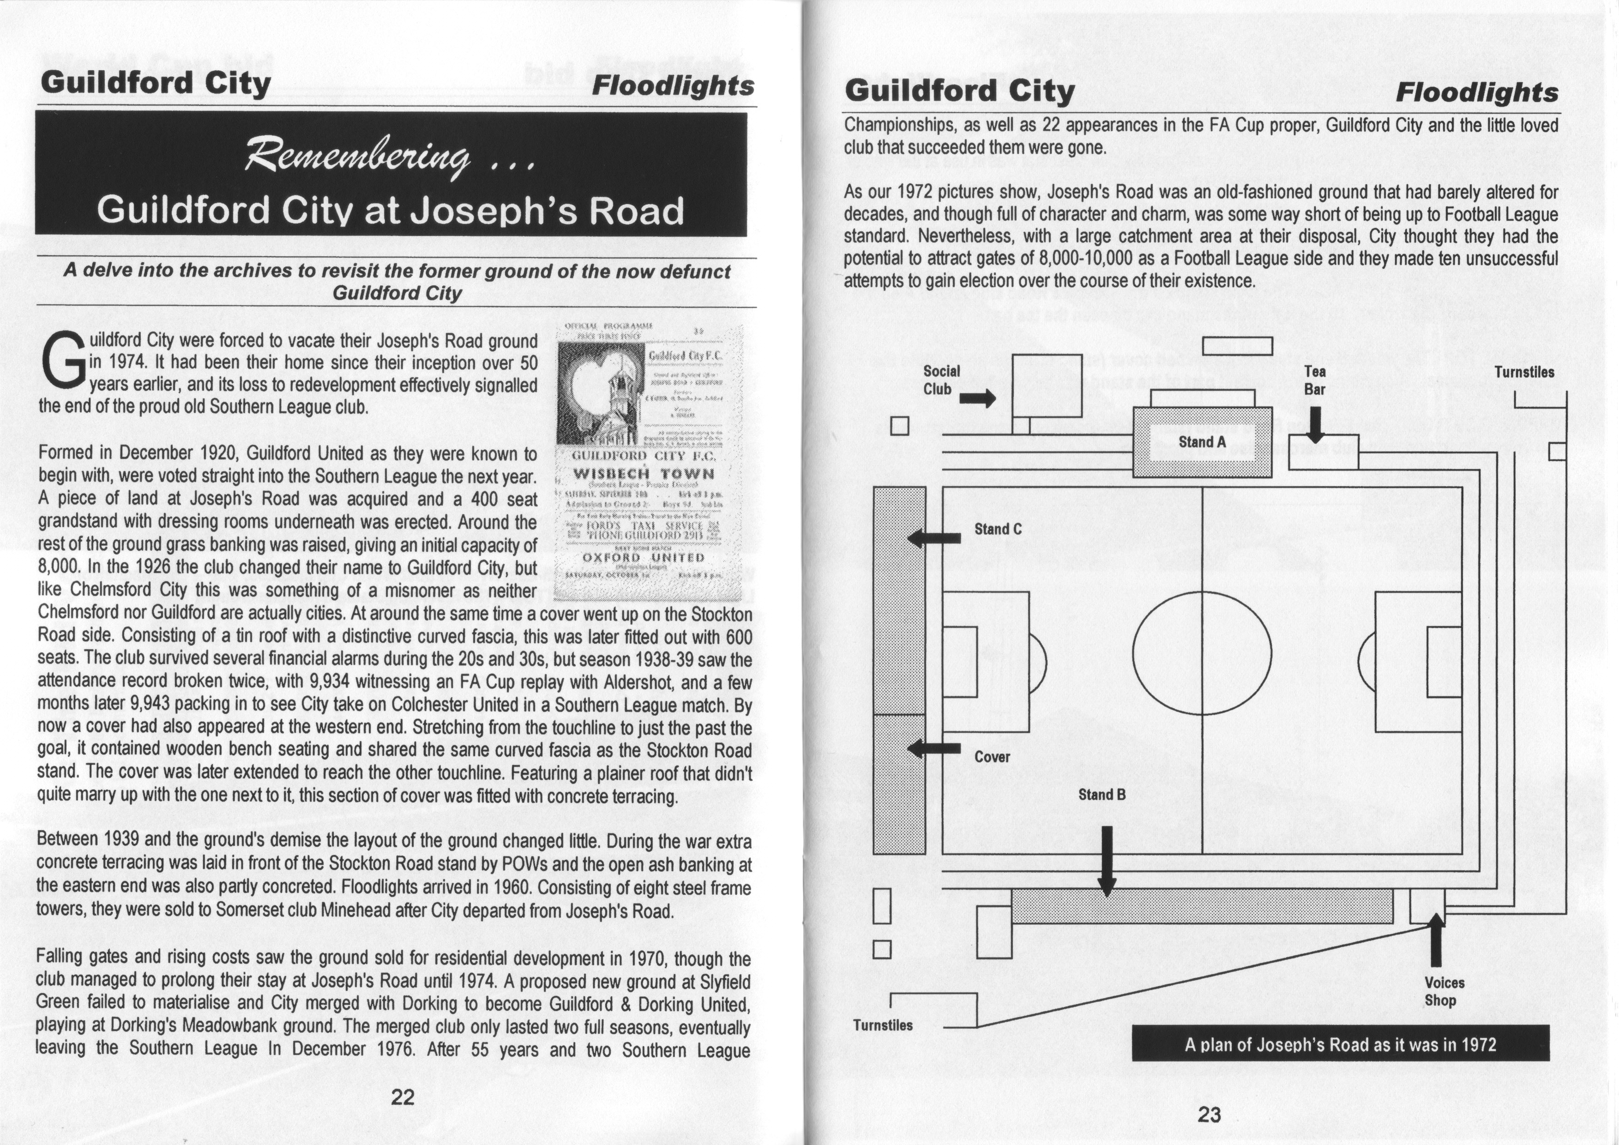

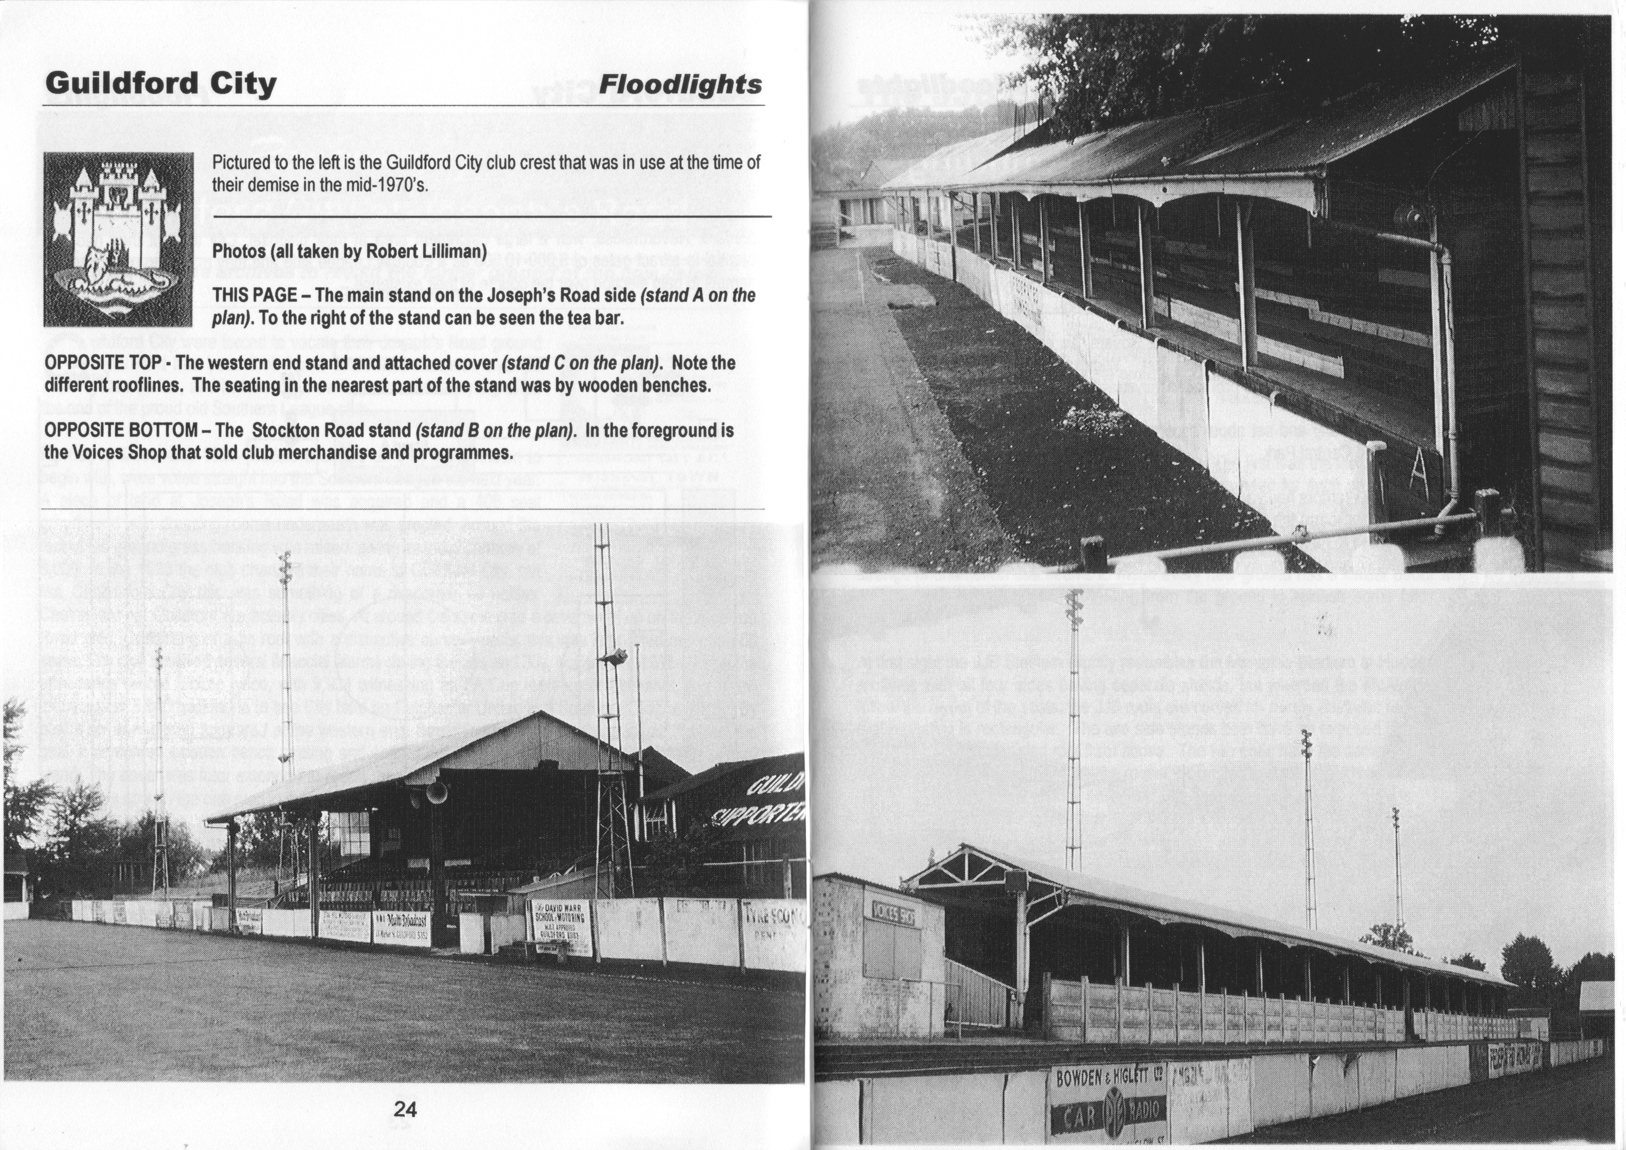

Matches against Guildford City
We have met a representative of a club by the name of Guildford City on 28 separate occasions.

The reason I have worded it like that is because 12 of those meetings were against their Reserve team in London League action either side of World War Two. Our closely linked Epsom Town, the club that shared our ground during WW2 also met them in 1939/40 Surrey Combination League action, losing both matches over Easter but still winning the title in the League’s one and only season.

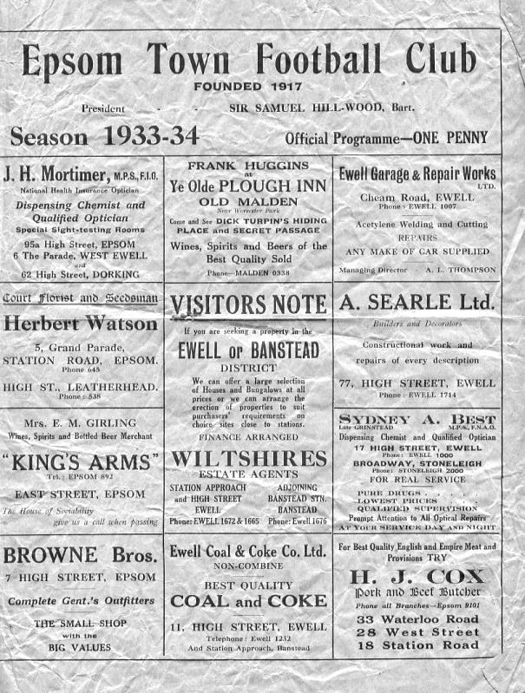
However, our very first meeting with them was against their first team and came on 13th October 1934 in the F.A. Cup. I don’t actually have a programme for the 1934/35 season at all, but I have one for the seasons before and afterwards and can confirm that it would have looked almost identical to this one. (pictured above)

Excitement was high in the town for this match. Just eleven months previously we had beaten a number of powerful Isthmian League outfits to reach the First Round Proper of the competition and wins over Carshalton Athletic, Redhill and Streatham Town after a replay had enabled us to reach the second qualifying round where we hosted our first ever Southern League team. We had met both Chelmsford and Romford by this time but neither had turned professional by this time and in fact Chelmsford were an earlier incarnation of the Chelmsford City we see today.

Anyway, I digress. 3,300 spectators were present to watch the match and we had a really good go at them, losing 4-2 but according to the Epsom Herald report (on facing page) we were only inferior in one department, that of scoring. We held our own and had led after 20 minutes through Hannam, the former Park Royal forward but only led for five minutes before Ives equalised and then five minutes later we trailed to a soft penalty, which Thom converted for the first of his three goals on the day.

In the second half we did much of the work but fell further behind and although Tommy Dunne reduced the arrears after 83 minutes, a late fourth goal for the visitors put a gloss on the score line. In another report, The Epsom Advertiser advises that we very nearly drew level before that fourth goal was scored.

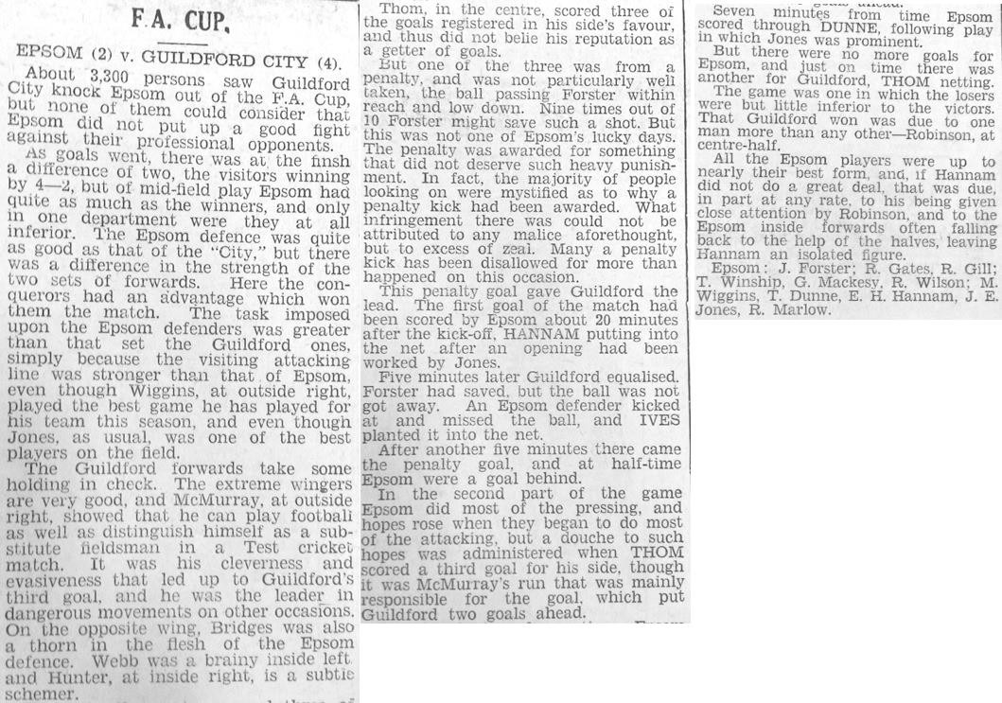

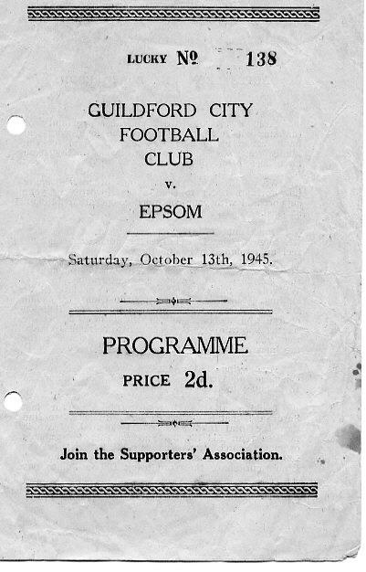
Our record in the London League was sound against the Guildford Reserve side, winning all four League matches in 1937/38 and 1938/39 although our first match against them following the hiatus did not end well, being crushed 8-1 at Josephs Road (see programme left) and although we won the return match 4-2 in March 1946, we were defeated four times in our next five matches, drawing the other. Our final meeting came on Easter Monday 18th April 1949, where we won 4-1.

We didn’t meet again until the 19th September 1970 when we were paired with their first team once again in an F.A. Cup tie. They were regulars in the later stages of the F.A. Cup whilst we had just started what would be our worst ever season in history. Looking back, it is quite amazing that we escaped with just a 5-0 defeat! (see programme below)

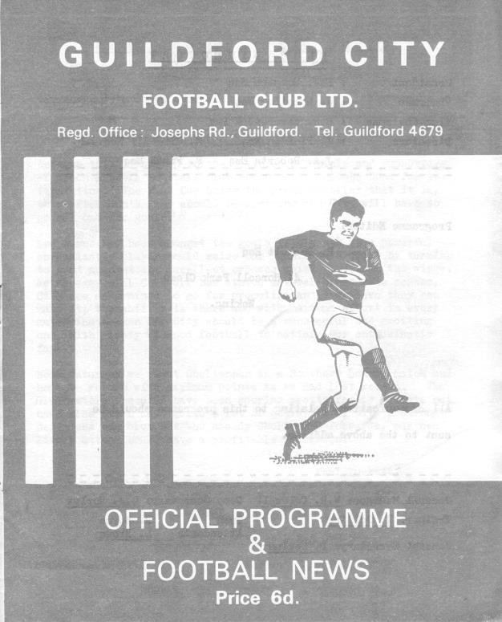
Our next meeting, as I am excluding a Surrey Senior Cup tie with Godalming & Guildford) was on 14th October 2006. The by now reformed Guildford City that we know today visited us at Merland Rise in our first season in the League, following the closure of the Ryman League Division Two. We were having a bad time of things but a goal from Jamie Watson followed by an injury time clincher from Adam Pero gave us our first win of the season although our first visit to the Spectrum was an unhappy won as we were smashed 4-0.

We both traded 1-0 home wins the following season before we completed a League double over them with a 4-0 win at Guildford in early August and

followed this with a Robbie Burns goal in our 1-0 home victory the following February.

We won again at a warm Merland Rise on the opening game of the 2008/09 season by two clear goals, with Alex McGregor and Mark Jarman amongst others making their debuts, but were narrowly edged out 2-1 in the return, losing to a dodgy penalty that also required our keeper Paul Borg to leave the field earlier than originally intended!

However, they were a decent team that season and would get stronger too in 2010/11. We couldn’t have met them at a worse time. Tuesday 14th September 2010 was the date and we entered after a frustrating F.A. Cup defeat at Hythe Town, who would eventually reach the First Round Proper, while Guildford had just won at Step Three side Tonbridge in the same competition. Our early goal just seemed to irritate them as they then scored five times in reply, although we didn’t help ourselves by getting both Darren Smith and Joe Paris sent off in this match at Moatside, Merstham F.C.

We lost the return fixture 3-1 as they became Champions that year, although the big story that day was our supporters sponsored walk from Epsom to Guildford. In 2011/12 we led through McGregor late in the game yet somehow lost 3-2 and although we recorded a fine 1-1 draw in April at the Spectrum to avoid any thoughts of relegation, Guildford won the league for a second straight year and this time went up.

Last season we won 4-1 at home against a team struggling to find their feet, but by the time of the return match in Guildford, both teams came in on four straight wins and we extended our sequence with a 3-1 win. Can we keep our recent good run going today?
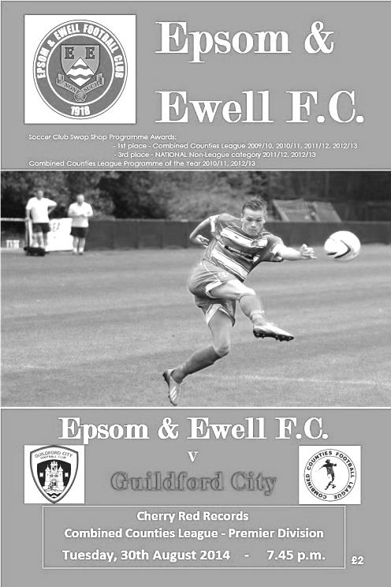
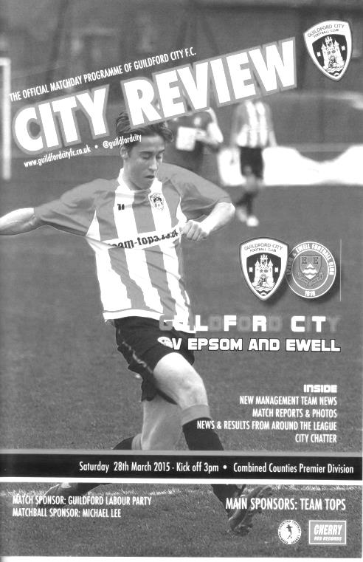

Surrey Senior Cup
Our successful Surrey Senior Cup winning team from 1981
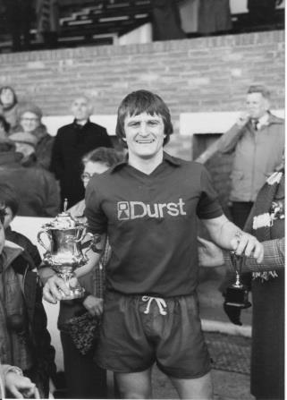
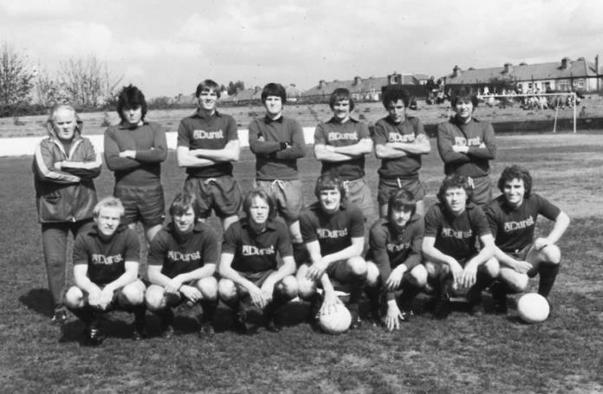
First Round
Ashford Town (Mx) | 3-1 | Beckenham Town
Camberley Town | 1-1 | Knaphill
Knaphill won 3-2 on penalties
Epsom & Ewell | 1-6 | Dorking Wanderers
Second Round
Knaphill | 4-3 | Ashford Town (Mx)
Chipstead | 4-1 | Chessington & Hook United
Colliers Wood United | 1-3 | Whyteleafe
Corinthian Casuals | 1-1 | Egham Town
Corinthian Casuals won 4-2 on penalties
Croydon | 3-3 | Farnham Town
Farnham Town won 3-2 on penalties
Godalming Town | 1-0 | Guildford City
Horley Town | 2-2 | Badshot Lea
Badshot Lea won 4-3 on penalties
Leatherhead | 3-0 | Carshalton Athletic
Merstham | 3-0 | South Park
Met Police | 3-2 | Dorking Wanderers
Molesey | 2-1 | Raynes Park Vale
Redhill | 0-3 | Tooting & Mitcham United
Sutton United | 3-0 | Walton & Hersham
Walton Casuals | 1-1 | Kingstonian
Kingstonian won 9-8 on penalties
Westfield | 2-0 | Chertsey Town
Woking | 10-0 | Sutton Common Rovers

F.A. Vase
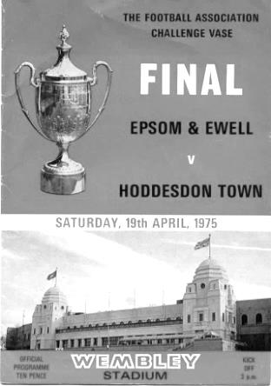
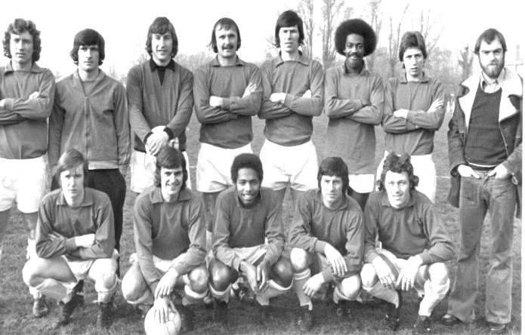
Third Round – 12th December
Marske United | V | Team Northumbria
Sunderland RCA | V | Tadcaster Albion
Newton Aycliffe | V | Atherton Collieries
South Shields | V | Morpeth Town
North Shields | V | Runcorn Town
Dunston UTS | V | Seaham Red Star
Alsager Town | V | AFC Wulfrunians
St Andrews | V | Leicester Nirvana
Handsworth Parramore | V | Cleethorpes Town
Pinxton | V | Nuneaton Griff
Walsall Wood | V | Alvechurch
Uttoxeter Town | V | Coleshill Town
Hereford | V | Brocton
Saffron Walden Town | V | Berkhamsted
FC Broxbourne Borough | V | Bowers & Pitsea
Hullbridge Sports | V | Stanway Rovers
AFC Dunstable | V | Basildon United
Edgware Town | V | Ipswich Wanderers
Yaxley | V | Sleaford Town
Hertford Town | V | FC Romania
Colliers Wood United | V | Hartley Wintney
Thame United | V | Kidlington
Ascot United | V | Camberley Town
Lordswood | V | Ashford United
Eastbourne Town | V | Sutton Common Rovers
Tadley Calleva | V | Newport (IW)
Canterbury City | V | Knaphill
Moneyfields | V | Brimscombe & Thrupp
Buckland Athletic | V | Bradford Town
Highworth Town | V | Salisbury
Welton Rovers | V | Bodmin Town
Bristol Manor Farm | V | Hengrove Athletic

Player Sponsorship
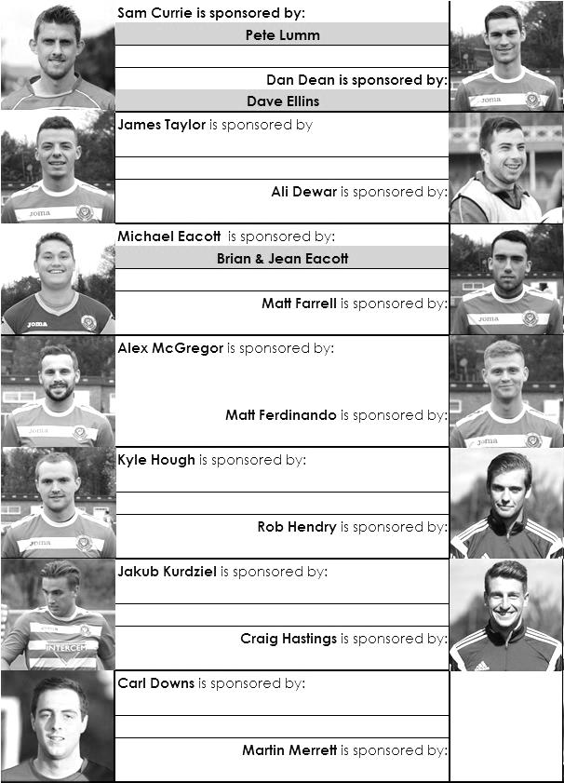

Here is the current list for the 2015/16 season showing all of our players and Management that are currently available for sponsorship this season.

Sponsorship costs just £40 and it is easy to do. Just select a player who has not been previously sponsored and let a Committee Member know that you would like to sponsor them. Beware though. Until we have received the money it is possible for someone to jump in front of you, so don’t delay, sponsor today!

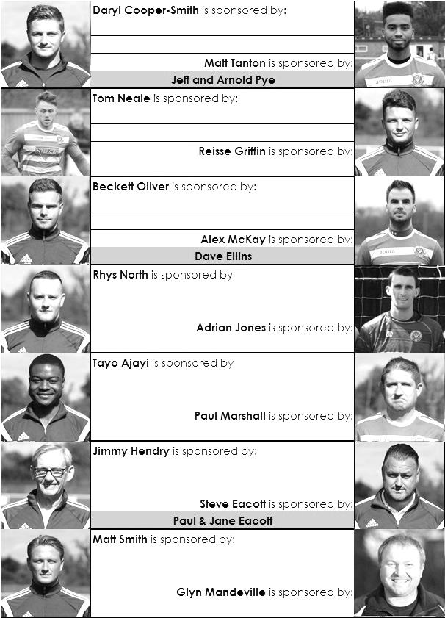

Match and Ball Sponsorships – 2015/16
Opponent | Date | Match and Match Ball Sponsor
Hoddesdon Town | 18/07/15 | Geoff Dyke
Windsor | 08/08/15 | Club President Stella Lamont
Erith & Belvedere (FAC) | 16/08/15 | Mike Lovett
Raynes Park Vale | 31/08/15 | EEFC Management Committee
Colliers Wood United | 08/09/15 | Bookham Building Shop – www.buildingshop.co.uk
AFC Hayes | 19/09/15 | John Bonner
Farnham Town | 26/09/15 | Ezara and Inaya Beddoe – our youngest supporters!
Chertsey Town | 17/10/15 | Club Media Officer – Richard Lambert
Dorking Wanderers (SSC) | 20/10/15 | Tony Ferdinando
Chessington & Hook United | 07/11/15 | Paul Merritt
Hanworth Villa | 21/11/15 | Maggie Beddoe
Guildford City | 05/12/15 | Pete Lumm
Cove | 08/12/15
Sutton Common Rovers | 19/12/15
Redhill | 02/01/16
Ashford Town (Mx) (LC) | 12/01/16
Spelthorne Sports | 16/01/16
Hartley Wintney | 30/01/16
Bedfont Sports | 13/02/16
Horley Town | 27/02/16
Knaphill | 12/03/16
Westfield | 26/03/16
Badshot Lea | 09/04/16
Camberley Town | 16/04/16
Ashford Town (Mx) | 30/04/16
For League, League Cup and Surrey Senior Cup Matches:
Match sponsorship - £40.00 Match ball sponsorship - £25.00. Combined £55.00.
For F.A. Cup and F.A. Vase matches:
Match sponsorship - £50.00 Match ball sponsorship - £30.00. Combined £65.00.

Sponsorship includes: (x2 for match, x3 for match and ball)

Admission, programmes, hospitality and advertising and mascot for the day (if required).
If you are interested, just speak to a Committee Member, or drop me an email at: richard.c.lambert@gmail.com


We also thank our Kit Sponsors INTERCEM

Latest Results Grid
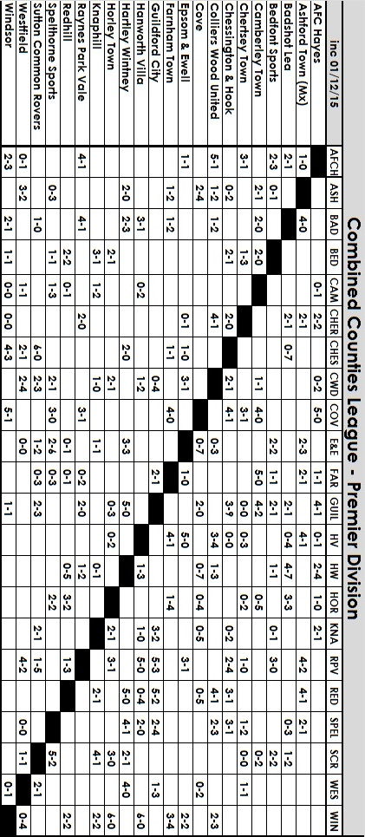

Birthday Corner
We have three player birthdays in December and two of them are on the same day!


Firstly, on the 3rd December we have Carl Downs who will have celebrated his 23rd birthday by the time you read this. He has just rejoined the club after some time away and already has over 100 appearances to his name from his first spell with us. He was also a member of our 2013 League Cup winning team. Welcome back Carl!

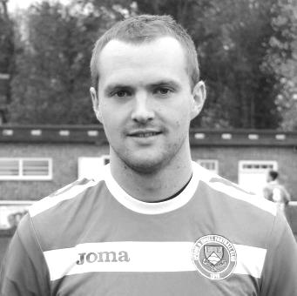
Kyle Hough, our resident goal scoring machine is celebrating his 28th birthday on Tuesday, 8th December and hopefully will hit a bucket load of goals on the day as we have a home match. Kyle is the third highest scorer in club history with 184 goals and although he has been hampered by a knee injury recently, he has an excellent strike rate this season, which we all hope will continue. On the appearance front he has just moved into eighth place on the all-time list with 329, recently passing other long-serving club men like Mick Stratford and Steve Delaney. Alan Webb is next up for Kyle to pass but he would need to play almost every game this season to pass his mark of 352. Here’s hoping!

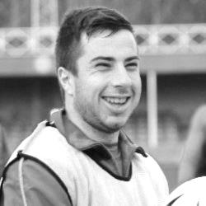
Also celebrating his birthday on the 8th is Ali Dewar. Ali has been with us for quite some time but has been badly affected by injuries in recent years. An indication of this is shown by his 90 appearances in four years with our club, during which time we have played just over 200.

He is currently working his way back to fitness after an ankle injury, where he had a bone spur growing there. It will be good to see him back on the field again as there are few quicker players out there.


Finally for this month, our Treasurer Steve Dyke celebrates his 50th birthday on Christmas Eve. Steve watched Epsom and Ewell at Wembley as a youngster and used to watch frequently when accompanied by his father and brother. Brother Geoff remains a regular face at our matches, both home and away.

Congratulations to all! Have a great day!

Salts Super Six Predictor
The Salts Super Six Predictor Competition is live again and the tickets are on sale at today’s game to the left of the gate. We recently had our second winner when Maggie Beddoe selected all six results correctly but the jackpot is already beginning to rise.

The competition is easy to play! To win, you simply need to predict the results of the six matches correctly from the three options, fill in the form and make sure it is back with our sellers before the deadline on the ticket.

If you are a club regular, you just need to place your name on the sheet, although if you aren’t, then we’ll need a contact number from you too. We will announce any winners on the website within three working days, so don’t worry we won’t miss you!
The jackpot is now at £82 and who knows how high it could go this time!

Please note that if there is more than one winner, the prize pot would be shared between the winners. All you need to do now is have a go, as many times as you like!

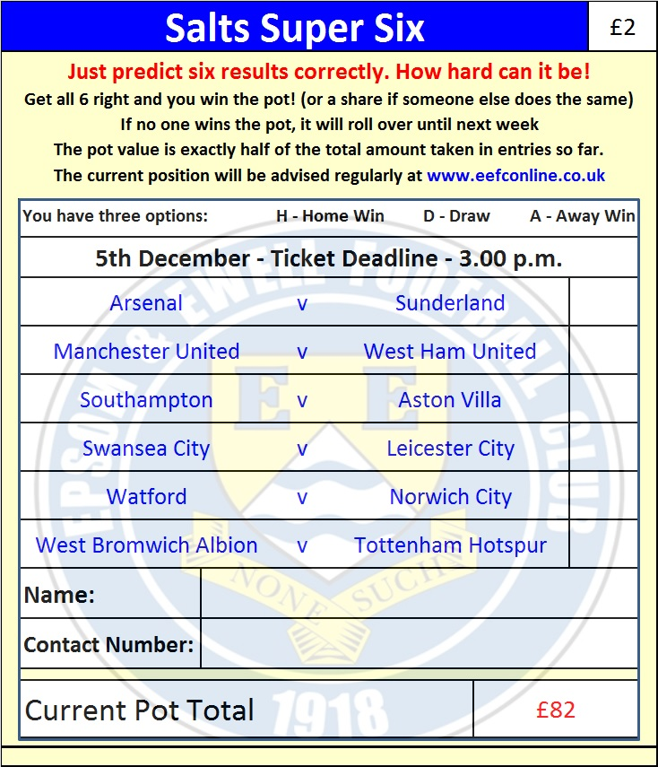

Good luck!

Combined Counties League – Premier Division
Saturday, 5th December 2015 - Kick-off 3.00 p.m.
Epsom and Ewell  (Royal Blue & White hoops) | V |  | Guildford City  (Yellow and Black)
Squad | NUMBERS
Michael Eacott |  |  | Liam Beach
© Sam Currie |  |  | Tom Booth
Matt Tanton |  |  | Liam Flanighan
Craig Hastings |  |  | Matt York ©
James Taylor |  |  | Martin Dynan
Dan Dean |  |  | Harry Driver
Alex McKay |  |  | Andy Ottley
Matt Farrell |  |  | Bradley Pegg
Kyle Hough |  |  | Matt Anton
Rob Hendry |  |  | Curtis George
Matt Ferdinando |  |  | Adam Nditi
Daryl Cooper-Smith |  |  | Nathan Chambers
Beckett Oliver |  |  | Josh Everard
Tom Neale |  |  | Remi Mongeaud
Carl Downs |  |  | Callum Sexton
Alex McGregor |  |  | Adam Turner
Reisse Griffin |  |  | Sanchez Benali
Rhys North |  |  | Kiyanu Pillay
Steve Rowe |  |  | Florin Ramizi
Tayo Ajayi |  |  | Nathaniel Williams
Jakub Kurdziel |  |  | James Davies
Glyn Mandeville | MANAGER |  | Dean Thomas
Matt Smith | ASSISTANT |  | Martin Dynan
Steve Eacott / Alex McKay / Jimmy Hendry | COACHES / PHYSIO |  | Mark Beach / Kieran Edwards
REFEREE: C.Vick (S.W. London)
ASSISTANTS: N.Walker (Addiscombe), K.Parker (Roehampton)
Today’s Match and Match Ball are sponsored by
long serving supporter and former Chairman Pete Lumm

OUR NEXT VISITORS TO HIGH ROAD ARE:
Cove F.C.
Tuesday 8th December 2015 - Kick-off 7.45 p.m.
Combined Counties League – Premier Division

